Draft Workplan for the Apalachicola-Chattahoochee-Flint River Basin Focus Area WaterSMART
October 7, 2011

TABLE OF CONTENTS
TABLE OF CONTENTS 2
TABLE OF FIGURES 5
TABLE OF TABLES 6
INTRODUCTION 7
BACKGROUND 9
SCOPE OF WORK 12
OBJECTIVES 13
METHODS AND APPROACH 14
Water Use 14
Compile Water Withdrawal Data for 1999-2011 16
Task 1. Non-Irrigation Withdrawals 16
Task 2. Irrigation Withdrawals 17
Task 3. Estimation based on Remote Sensing 17
Task 4. Estimation based on Irrigation Demands 18
Estimate Net Use 21
Task 5. Return Flows from Public Supply and Industrial Users 21
Task 6. Return Flows from Septic Systems 21
Task 7. Interbasin Transfers 23
Water Use Projections 23
Surface-Water/Groundwater Interactions 24
PRMS 24
Current Conditions Climate Data 24
Climate and Land Cover Projections 25
Modeling in the ACF River Basin 25
Task 1. PRMS module development 25
Model calibration 26
Task 2. Calibrate the PRMS model for natural flows 26
Task 3. Link PRMS with MODFLOW 26
Task 4. Incorporate water use 27
Task 5. Provide team members PRMS simulations streamflow conditions 27
Task 6. Document model development 27
MODFLOW 27
Modeling in the Lower ACF Basin 27
Calibration Procedure 27
Task 1. Develop MODFLOW input data sets for calibration 27
Task 2. Calibrate a transient MODFLOW model 28
Task 3. Calibrate MODLFOW using Stream Flow Routing (SFR) package 28
Task 4. The MODFLOW and PRMS models will be combined using a “soft” link 28
Climate Change Predictions 28
Task 5. PRMS predictions used to develop MODFLOW data sets 28
Task 6. Run MODFLOW for prediction period and coordinate with PRMS model 28
Coordination with Environmental Flows Team 28
Task 7. Refine MODFLOW model grid around biologically sensitive areas 28
Meeting the Vision of the WaterSMART Conceptual Plans for National Indicators and Environmental Flow Science 29
National Indicators 29
Environmental Flow Science 30
Environmental Flows 31
Advancing Environmental Flow Science 33
Work Tasks 34
Task 1. Sample native freshwater mussels and fishes 34
Task 2. Sample water quality at a subset of sites 36
Task 3. Update existing biological models 37
Task 4. Apply models to predict biological change 37
Task 5. Develop flow-ecological response curves 37
INFORMATION INTERCHANGE AND COMMUNICATIONS 39
Technical Team Interchange across Water Use, Surface-Water/Groundwater Interactions, and Environmental Flows 39
Products and Deliverables 39
Water Use 39
Surface-Water/Groundwater Interactions 39
Environmental Flows 40
TIMELINES 41
BUDGET 44
REFERENCES AND RESOURCES 45
APPENDICES 49
Appendix 1 50
ACF Synoptic: Field Data Collection in the Apalachicola-Chattahoochee-Flint and Northern Aucilla-Suwannee-Ochlockonee River Basins, southwestern Georgia and adjacent parts of Florida and Alabama 50
Introduction 50
Approach 50
Products 50
Appendix 2 53
Comparison/Combination of Models to Estimate Streamflow at Ungaged Basins 53
Introduction 53
Study Area 53
General Approach 53
Models 54
Statistically-based models (SBM) 54
Water Balance Model (WBM) 55
Precipitation Runoff Model (PRMS) 55
Model Calibration 56
Analysis 56
Products 56
Resources/Timeline 57
Appendix 3 57
Related Studies for Water Use 57
Appendix 4 60
Environmental Flows-ACF Context 60

TABLE OF FIGURES
Figure 1: Apalachicola, Chattahoochee, and Flint (ACF) River Basin with model extents for a MODFLOW groundwater model and both coarse and fine resolution PRMS surface-water models 9
Figure 2: Crack in the Woods Spring on the Chipola River. 10
Figure 3: ACF basin in the Dougherty Plain of southeastern Georgia, southwestern Alabama, and northwestern Florida and updip limit of the Upper Floridan aquifer. 11
Figure 4: Source, use, and disposition of water in a closed system (Fanning, 2007). 15
Figure 5: Example of Landsat-based estimates of ET for a portion of Arkansas on June 21, 2009. The area for which irrigation application data are available is outlined in black. These data are being used to develop estimation techniques that will be further refined using data from the GaMP in the ACF. 18
Figure 6: Process for estimating irrigation demands using crop type, acreage, and weather conditions 19
Figure 7: Streamflow hydrograph showing stormflow and baseflow components at Redland Creek near Lawrenceville, Georgia. This site is located near the ACF basin and demonstrates similar streamflow characteristics to ACF streams. 22
Figure 8: Streamflow hydrographs showing baseflow conditions during wet, dry, and normal conditions for a site on the Canoochee River near Claxton, Georgia (modified from Priest, 2004). 23
Figure 9: Flow chart for evaluating the Ecological Limits of Hydrologic Alteration (ELOHA) (from: Conservation Commons; http://conserveonline.org). 33
Figure 10: ACF basin outline showing hydrologic response units for a basin-wide model of surface flows, and stream networks for six sub-basins where fine-resolution, “unimpaired flow” models have been developed as part of SERAP, and where biological sampling efforts will focus. Sub-basins are, from headwaters to downstream: upper Chattahoochee R., Chestatee R., Potato Cr., Ichawaynochaway Cr., Spring Cr., and Chipola R. 35
Figure 11: Hypothetical flow-ecology response curves, showing percent decrease in fish species occupancy versus percent change in a streamflow component, for fish species with three life-history strategies. Blue lines represent hypothetical limits of uncertainty for opportunistic species, for illustration. Similar curves could be simulated for streams with differing characteristics (e.g., small vs. large streams, confined vs. unconfined, physiography or water quality classes), depending on the strength of evidence that these covariates modify species responses. 38
Figure 12: Surface water sites measured as part of the synoptic. 51
Figure 13: Groundwater sites measured as part of the synoptic. 52
Figure 14: Locations of permitted unmetered and metered agricultural water-use sites in the middle-and-lower Chattahoochee and Flint River basins at the end of 2009 (From Torak and Painter, 2011). 59
Figure 15: Outline of ACF basin in relation to provinces and southeastern states. 61

TABLE OF TABLES
Table 1: Timeline for Water Use Team; * = date of 11/18/2011; ** = date of 06/04/2012 41
Table 2: Timeline for Surface Water/Groundwater Interactions Team 42
Table 3: Timeline for Environmental Flows Team 43
Table 4: Experiments proposed for model comparisons. 54
Table 5: Crayfishes of the ACF basin and conservation status as recognized by the American Fisheries Society (Taylor and others, 2007). CS = currently stable; V = vulnerable; T = threatened; E = endangered; † = species complex currently under study). Crayfishes are not targeted in the present study; however, many rheophilic species share vulnerability to hydrologic alterations in common with other aquatic fauna. 61
Table 6: Imperiled fishes of the ACF basin as recognized by the American Fisheries Society (Warren and others, 2000, Jelks and others, 2008). V = vulnerable; T = threatened. 62
Table 7: Freshwater mussels (Unionidae) of the ACF basin and conservation status as recognized by the U.S. Fish and Wildlife Service (USFWS) and the American Fisheries Society (in prep.). V = vulnerable; T = threatened; E = endangered. 63

INTRODUCTION
The overarching purpose of WaterSMART is to develop data and tools needed by water resource managers to meet challenges imposed by aging infrastructure, population growth, groundwater depletion, impaired water quality, water needs for human and environmental uses, and climate variability and change. The aim is also to advance the science needed by stakeholders to assess ecological outcomes of management actions that change streamflow regimes and to forecast ecological conditions under future scenarios of water availability and management
The objective of WaterSMART is to place technical information and tools in the hands of stakeholders so that they can make decisions on water availability. The USGS is to focus on the technical aspects of providing this information. The main questions that WaterSMART will attempt to address are (1) does the nation have enough fresh water to meet the current needs of human and ecological demands, and (2) is there enough fresh water to meet the future demands? An accurate “water budget” can aid in providing pertinent information on water availability and in identifying areas where further study or work needs to be done. The long-term goal of WaterSMART is to provide stakeholders with a nationwide database that would deliver information about each piece of the water budget such as precipitation, evapotranspiration, storage, runoff, baseflow, surface water, groundwater, ecological needs, water withdrawals and returns.
Three focus areas have been identified for the first round of studies including the Upper Colorado River Basin, the Delaware River Basin, and the Apalachicola-Chattahoochee-Flint (ACF) River Basin. Each focus area will receive $500,000 per year for three years starting in FY 2012. Up to an additional $200,000 per year may also be available for ecological work in each focus area for the three year period.
This plan addresses the ACF River Basin. Three science themes have been identified to improve technical understanding of the ACF, (1) water use in its various forms (2), surface-water and groundwater interactions, and (3) environmental flows which aid in understanding the extinction/colonization dynamics of fishes/mussels, flow regime and water quality relations to ecology. For each of these themes, a corresponding team was organized and each team developed an approach which, when combined, will meet the objectives of WaterSMART. The teams are: the Water Use Team, the Surface-Water/Groundwater (SW/GW) Interactions Team and the Environmental Flows Team.
The Water Use Team will compile and develop techniques to better estimate water withdrawal and consumptive use information for the ACF basin in Alabama, Florida, and Georgia. Knowing how much water is withdrawn, consumed, lost, transferred, and disposed of is necessary for effective resource management (Fanning, 2007). Improved water-use information will facilitate estimation of a water budget for the ACF basin and serve as input to the SW/GW Interactions Team. This team is developing and expanding on existing numerical models to understand surface-water and groundwater interactions as part of the WaterSMART study in the ACF to assess the availability of water resources in the basin. The output from the SW/GW models is necessary input to the “environmental flows” component of WaterSMART, which will be lead by the Environmental Flows Team. The work done by this team will provide capabilities to assess and forecast ecological responses to changes in streamflow regimes as this forms a key component of sustainable water management. Whether streamflow regimes change as a result of management actions (such as allocations of water to offstream uses) or because of climatically driven shifts in amounts and timing of precipitation, the ecological responses may involve an array of interconnected processes (e.g., nutrient uptake and transport, sediment erosion and deposition, production and decomposition). Net effects often include changes in the ability of freshwater-associated ecosystems (streams and rivers, and downstream lakes, wetlands, estuaries and bays) to support fish and wildlife populations. Management issues arise when ecological changes involve losses of species valued for recreational fishing or commercial harvest, or when waterways no longer meet State and Federal definitions of chemical, physical and biological integrity, or when imperiled species decline toward extinction. Thus, the concept of “water needs for environmental uses” includes streamflow regimes necessary to sustain desired ecological conditions.
Conducting this work in the ACF basin will allow researchers to use data and models recently developed as part of a USGS Science Thrust project in the Flint River basin (Gregory and others, 2006, Hughes and others, 2007), and also the Southeast Regional Assessment Project (SERAP; Dalton and Jones 2010), which have included a focus on potential effects of climate and land use change on streamflows and aquatic biota in the ACF. The ACF is also of interest because the basin’s streams, rivers and groundwater systems are critical for meeting multiple, sometimes competing, objectives that include drinking water, irrigation, power production, industry, recreation, sewage disposal, and habitats for a diverse array of fishes, invertebrates and other wildlife. Improving the scientific basis for understanding potential effects of management actions on stream- and river-dependent biota is viewed as a key component to developing water management agreements that bridge multiple societal demands. Tools developed through research in the ACF basin should also have broad relevance and applicability to environmental flow issues elsewhere.

BACKGROUND
The Apalachicola–Chattahoochee–Flint (ACF) River Basin (Figure 1) encompasses a long, narrow area of about 19,256 square miles (mi²), mostly in western Georgia and partly in southeastern Alabama and northwestern Florida (Jones and Torak, 2006). The Chattahoochee and Flint Rivers are tributaries to Lake Seminole, a human-made impoundment located at the Georgia-Florida State line that provides headwater to the Apalachicola River. In contrast to the Flint, the majority of the Chattahoochee River is highly regulated by the operation of 16 mainstem dams, which are used for hydropower generation, flood control, water supply, transportation, and maintenance of minimum flows.
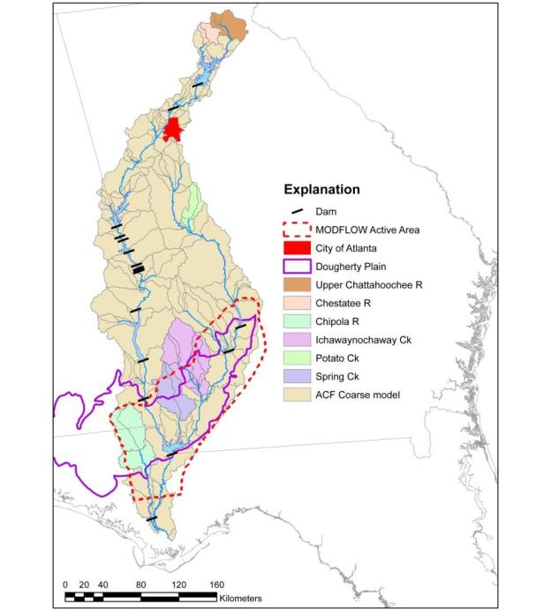
Figure 1: Apalachicola, Chattahoochee, and Flint (ACF) River Basin with model extents for a MODFLOW groundwater model and both coarse and fine resolution PRMS surface-water models
The Apalachicola River flows from Lake Seminole about 107 miles (mi) southward through the panhandle of northwestern Florida to the Gulf of Mexico. Flow in the Apalachicola River is important to the ecology and economy of the region surrounding the floodplain and estuary and the ACF supports populations of rare fish and mussels. Its floodplain is one of the most biologically diverse areas in the U.S. containing 116 plant species of which 45 are listed as threatened or endangered, and an additional 30 are considered rare.
The principal rivers and tributaries in the lower basin drain karstic and fluvial plains and are hydraulically connected to the Upper Floridan aquifer, one of the most productive carbonate aquifers in the United States. Hydraulic connection of the aquifer with surface water in the lower ACF River Basin occurs directly through many karst sinks, sinkhole ponds, and conduits that expose the carbonate aquifer at land surface (Figure 2). Many springs feed streams that flow directly on top of the limestone of the Upper Floridan aquifer, and these streams contain gaining and losing reaches that change seasonally along relatively short distances. Some streams disappear into limestone sinks and caverns, flow underground in the aquifer, and then reappear in solution openings in the limestone. The Upper Floridan aquifer contains nearly 100,000 mi³ of predominantly karst limestone (Bush and Johnston, 1988) and is the primary source of groundwater for agriculture, industry, and public supply in the lower ACF River Basin (Figure 3). Indirect hydraulic connection of the aquifer with surface water occurs by leakage through undifferentiated overburden consisting of alluvium and chemically weathered limestone (residuum), which mantles the aquifer throughout much of the ridged area.
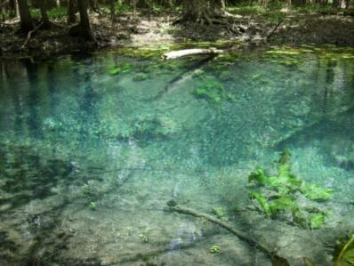
Figure 2: Crack in the Woods Spring on the Chipola River.
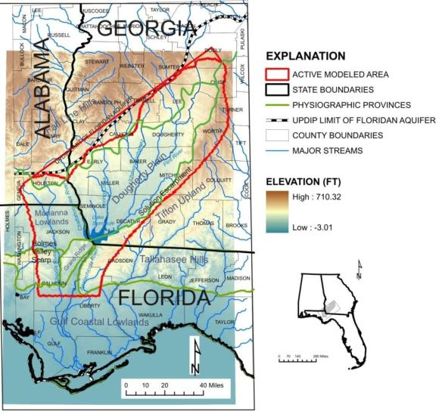
Figure 3: ACF basin in the Dougherty Plain of southeastern Georgia, southwestern Alabama, and northwestern Florida and updip limit of the Upper Floridan aquifer.
In the northern part of the ACF basin, surface water is the major water source, with Lake Lanier impounding a large percentage of the basin-wide available storage. Major water users include the city of Atlanta, as well as Gwinnett, DeKalb, Fulton, and Cobb Counties. In these four counties over 333 million gallons per day (MGD) was withdrawn during 2005, primarily for public supply. In the lower part of the basin, groundwater is the principal water source mainly irrigation pumpage in this heavily agricultural region. Nearly 780 mi² are irrigated with groundwater from about 4,000 wells completed in the Upper Floridan aquifer (Torak and Painter, 2006). During 2002, groundwater withdrawal from the Upper Floridan aquifer in the Flint River Basin averaged about 340 MGD (Hook and others, 2005). Because of the karst setting in much of this area, ground and surface waters are highly interconnected and pumping for irrigation directly impacts surface-water flows.

SCOPE OF WORK
As part of WaterSMART, the USGS will perform a focused area study on the Apalachicola-Chattahoochee-Flint River Basin in Alabama, Florida, and Georgia, where significant competition exists over water resources. In Georgia, the study area includes the Piedmont and Coastal Plain Physiographic Provinces, whereas in Alabama and Florida, the study area lies in the Coastal Plain. Here, the USGS will work collaboratively with stakeholders to comprehensively assess water budgets and water availability under current hydrologic, climatic, land-use, and water-demand conditions; potential climatic scenarios; and possible land-use changes.

OBJECTIVES
WaterSMART is part of the Water Census, which has three main objectives:
The first is to provide a nationally consistent set of indicators that reflect each status and trend relating to the availability of water resources in the United States. This objective includes substantial work on improving our knowledge of water use throughout the United States. The second objective is to provide information and tools that allow users to better understand the flow requirements for ecological purposes. And the third objective is to report on areas of significant competition over water resources and the factors that have led to the competition.
To achieve the objectives of WaterSMART; the ACF teams propose the following.
- Water Use: First, improve understanding of current withdrawals and return flows in the ACF basin and contribute to a better understanding of the water budget. This information will be utilized in the numerical models being used in the ACF study. Estimating and understanding withdrawals involves:
- Compilation of available water withdrawal and return flow data for 1999-2011
- Development of new methods to estimate agricultural withdrawal
- Estimation of net water use
- Estimation of projected future demand

- Surface-Water/Groundwater Interactions: Second, achieve an understanding of SW/GW interactions by coupling a surface-water model with a ground-water model. Ultimately, the modeling will enable estimation of a water budget and assessment of water availability, while also providing streamflow for the environmental flows portion of the study. The primary objectives of the modeling are:
- Simulation of land-surface hydrologic processes, including evapotranspiration, runoff, infiltration, interflow, snowpack, and soil moisture on the basis of distributed climate information (temperature, precipitation, and solar radiation)
- Simulation of hydrologic water budgets at the watershed scale with temporal scales ranging from days to centuries
- Integration with models used for natural-resource management or other scientific disciplines
- Creation of a modular design that allows the selection of alternative hydrologic-process algorithms from either the standard module library or user-provided provisional modules.
- Environmental Flows: Third, assess and forecast ecological responses to changes in streamflow regimes and water quality. This “environmental flows” research will be integrated with two previous components discussed above: developing and updating water use information for the ACF, and modeling surface-water/groundwater interactions. Specific objectives of the environmental flows component are to:
- Evaluate hypotheses concerning effects of hydrologic alteration on stream fish and mussel populations, using existing and newly collected data for differing physiographic regions of the ACF basin.
- Evaluate new approaches for integrating effects of variation in water quality into models of ecological response to hydrologic alteration using data collected that advances current understanding based on correlations between water quality and biological condition.
Together, these three components are intended to improve the quality and accessibility of information on water availability for humans and ecosystems in the ACF basin, and to advance technical water assessment capabilities.

METHODS AND APPROACH
To achieve the aforementioned objectives, this project has been divided into three teams:
- Water Use Team,
- Surface-Water/Groundwater Interactions Team, and
- Environmental Flows Team
The goal is to make sure that each topic is thoroughly covered by experts in that particular field, while simultaneously assuring that the teams are interacting. Timely information interchange is critical to achieving the goals of the WaterSMART ACF focus area study. The SW/GW Interactions Team will incorporate the water use information compiled by the Water Use Team to improve simulations of current and future streamflows throughout the ACF basin. The SW/GW Interactions Team will provide streamflow statistics to the Environmental Flows Team for use in their models. It is critical that the data produced by each team are output and formatted in a manner that can be readily used by other teams. Excessive amounts of formatting and compiling of information by the next team to use results from the previous team could threaten project timelines.
The methods and approach for each individual Team are discussed below.

Water Use
The USGS defines consumptive water use as water which is evaporated, transpired, incorporated into a product or a crop, consumed by humans or animals, or otherwise removed from the immediate environment and is therefore not immediately available for reuse (Hutson and others, 2004, p. 44). A related concept to consumptive use that is more appropriate for basin water-budget determinations is the “net use” approach whereby net use represents the difference between all water withdrawn from a river basin and all water returned to the basin (return flow) in a given water-use timeframe, and is thus the net effect of all withdrawals and return flows (Fanning, 2007). The net use calculation includes inter-basin transfers, groundwater discharged from supply systems to streams (i.e. withdrawn from a well and discharged into a stream), and septic-system usage. Groundwater flow moving from one river basin to another should also be considered in net use computations. Figure 4 is a schematic diagram showing how water moves through a closed water-use system from withdrawal to discharge.
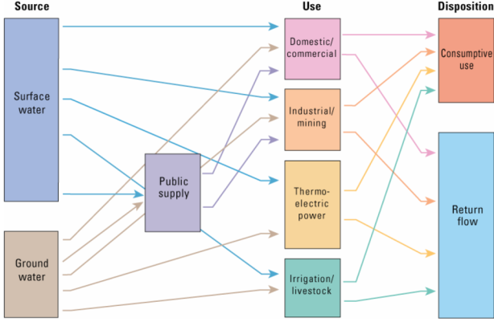
Figure 4: Source, use, and disposition of water in a closed system (Fanning, 2007).
Interbasin transfers are an important part of net use computations. In Georgia, interbasin transfers have existed since the early 1900s, with most resulting from public supply use in the metropolitan Atlanta region (Draper, 2005). The river basins in metropolitan Atlanta are long and narrow, and many public-supply systems extend over more than one basin. In several instances, systems withdraw water from one basin and discharge water into a different basin. The Metropolitan North Georgia Water Planning District (2011) estimates that 56 to 79 percent of withdrawals from the Chattahoochee River in the water district were returned to the river during 2000-2009.
Septic systems may also influence net use computations. In the metropolitan Atlanta region, an estimated 26 percent of the single-family housing units are served by septic systems—a higher percentage than is typical of most large cities in the United States (U.S. Department of Housing and Urban Development and U.S. Census Bureau, 2005). Septic systems in metropolitan Atlanta were previously assumed to be fully consumptive, meaning no water returns to streams; however, studies by Landers and Ankcorn (2008) indicate that groundwater contribution to streamflow was 90 percent higher in watersheds with high densities of septic systems than in watersheds with low densities. The Landers and Ankcorn (2008) study was conducted in Gwinnett County, Georgia, adjacent to the ACF basin, in an area with similar geologic and hydrologic setting.
Net use varies from the upper to lower parts of the ACF basin. In the northern part of the basin, upstream from Columbus, GA, water supply is derived from mostly surface-water sources and the largest loss of water is from public-supply systems, with substantial interbasin transfers. In the lower part of the basin, south of Columbus, GA, groundwater is the primary water source and the largest loss of water is from irrigation, which is assumed 100 percent consumptive (Landers and Painter, 2007). Streamflow and net use can vary by hundreds of percent from year to year and season to season. Net use typically is highest during droughts and summer months when streamflow is typically low (Landers and Painter, 2007).
The general approach will be to compile available withdrawal and return flow data, and to estimate data where it is missing. Detailed descriptions of individual tasks are provided below.

Compile Water Withdrawal Data for 1999-2011
Available water-withdrawal data will be compiled for the period 1999-2011 to help develop surface-water and groundwater models for the study area. As part of the 5-year National water-use report, each USGS Water Science Center is charged with compiling water withdrawals on a county basis by category of use and according to source (surface water or groundwater). The 5-year report includes already published data for 2000 and 2005 and is currently compiling withdrawal data for the year 2010; additional data will be compiled for the years 1999, 2007-2009, and 2011. Annual withdrawal data for 1999 and monthly data for 2001-2002 have already been compiled for Georgia as part of a groundwater modeling study by Jones and Torak (2006).

Task 1. Non-Irrigation Withdrawals
The focus area study will build on the 2010 aggregated data compilations for Alabama, Florida, and Georgia by creating SWUDS databases of site-specific withdrawals that are consistent with aggregated estimates. In the three states, site-specific or facility-specific withdrawal data are available for most public supply, major industrial and mining, and thermoelectric power water users. Major tasks include:
- Develop master lists of major water users within the basin
- Determine available withdrawal site (wells, springs, and intakes) data for the major users
- Determine available site- or facility-specific data for the major users for 2010 from the data compiled for the National 5-year water-use report, including monthly data which will assist in analysis of seasonality effects of water use and water availability
- In addition to the 2010 compilation, available data for 1999, 2000, 2001-2002, 2005, 2008, 2009, and 2011 will be compiled
- Create SWUDS databases in each State
  - Develop SWUDS data models to accommodate the variety of available data, site information, and user types
  - Determine new withdrawal, place-of-use, and outfall sites which must be created in each database
  - Create tracking network linking water source sites to place-of-use sites; link outfall sites when possible
  - As 2010 withdrawal data becomes available as part of the effort on the national water-use report, input this data into SWUDS. Input data for 1999, 2000, 2001-2002, 2005, 2008, 2009, and 2011 into SWUDS

Task 2. Irrigation Withdrawals
In Georgia, data from the Georgia Metering Program (GaMP) will be compiled for 2008-2011. However, there is no equivalent data set available in Alabama or Florida, so techniques will be developed and tested to estimate withdrawals in other areas.
The GaMP data and reported irrigation withdrawal from Florida will be used to evaluate techniques for estimating irrigation withdrawal based on climatic data, crop acreage and crop-specific application rates, and satellite image processing techniques (See Tasks 3 and 4: “Estimation based on Remote Sensing” and “Estimation based on Irrigation Demands”).
To provide information on irrigation withdrawal in areas not covered by a metering program, two estimation techniques will be developed. The first will involve estimation based on remote sensing data and the second will involve estimation based on crop type and irrigation demand. Each of the two methods will be compared to data from the GaMP to evaluate the goodness of fit of the estimates. The ACF pilot will also allow the comparison of these two approaches to one another and the potential development of hybrid techniques.
The first step in development of estimation techniques for irrigation withdrawal is to develop a database using GaMP and Florida data and available crop information. Data from USDA and state agencies, GaMP, and Florida irrigation withdrawal will be compiled into a GIS database. This database will provide information required for both estimation techniques.

Task 3. Estimation based on Remote Sensing
Following prototype work currently being conducted in the Yazoo River Delta region of Arkansas and Mississippi (Figure 5), maps of latent heat (LE) created from moderate spatial resolution satellite imagery using variations on Crop Water Stress Index (CWSI) approaches (for example, Kustas and others, 1994) will be statistically analyzed to identify irrigated lands and estimate water use through irrigation. CWSI approaches have the advantage that they require little meteorological data and are relatively simple to estimate (as opposed to energy balance approaches) such as Surface Energy Balance Algorithm for Land (SEBAL; Bastiaanseen and others, 1998) or Mapping Evapotranspiration at high Resolution and with Internalized Calibration (METRIC; Allen and others, 2005). This approach has the following subtasks:
- Partition GaMP irrigation data into algorithm development and algorithm evaluation subsets through stratified random sampling followed by evaluation dataset quality assessment.
- Construct a calibrated moderate-resolution satellite database that corresponds to the time frame of the algorithm development data subset for the targeted study areas.
- Model LE using project developed software.
- Generate LE estimates for calibrated satellite image dates.
- Develop statistical relationships (e.g., regressions) among GaMP data and satellite-data.
- Map irrigated lands based on statistical relationships and evaluate map accuracy using algorithm evaluation data subset.
- Combine irrigated land map data and LE simulations to estimate total water use for irrigation.
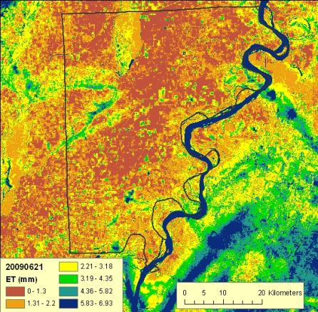
Figure 5: Example of Landsat-based estimates of ET for a portion of Arkansas on June 21, 2009. The area for which irrigation application data are available is outlined in black. These data are being used to develop estimation techniques that will be further refined using data from the GaMP in the ACF.

Task 4. Estimation based on Irrigation Demands
Another approach for estimating agricultural irrigation withdrawals is based on the assumption that actual withdrawals are directly proportional to irrigation demands. Irrigation demands are, in turn, estimated as a function of (1) the types of crops grown, (2) their respective irrigated acreages, and (3) weather conditions. Once irrigation demands are estimated for these three basic categories of data, they can then be compared with reported data to assess the accuracy of the estimated demands, including the potential for the presence of bias in the estimates. A schematic diagram showing the process for estimating irrigation demands using this procedure is shown in Figure 6. This approach has the benefit of using readily available, spatially-distributed data that could be used to estimate reference crop ET as well as the demands of individual crops as far back as the late 1800’s. This could be especially useful for developing the datasets necessary for model simulations of historical conditions or the range of conditions that might be experienced in the future.

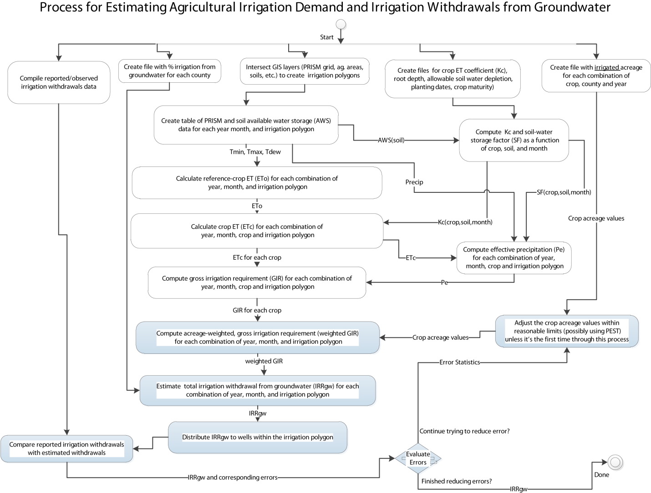
Figure 6: Process for estimating irrigation demands using crop type, acreage, and weather conditions
In this approach, irrigation demand is first computed for an individual county as the area weighted-sum of the gross irrigation requirements of individual crops. The gross irrigation requirement (GIR) of an individual crop is equal to its net irrigation requirement (NIR) divided by the efficiency of the irrigation method. Net irrigation requirement (NIR) is further defined as the difference between effective precipitation and crop evapotranspiration (NIR = P_{eff} – ET_{crop}). Crop evapotranspiration is computed by first estimating the reference-crop evapotranspiration. In the proposed study, reference crop ET will be computed using a version of the Penman-Monteith method (Allen and others, 1998). Allen and others (1998) describe how the this method can be used to compute reference-crop ET estimates for time steps of 10-days or longer using air temperature, relative humidity (or dew point temperature), and wind speed data. Crop ET is then estimated by multiplying the monthly reference crop ET estimate by a crop ET coefficients (ET_{crop} = K_{c}*ET_{ref}, where K_{c} is the crop ET coefficient). Effective precipitation will be computed as a function of monthly precipitation, ET_{crop}, and usable soil-water storage (United States Department of Agriculture, 1993, p. 2-147). Usable soil-water storage will be calculated by integrating available soil-water storage over the rooting depth for a given crop and soil, and then multiplying the result by the allowable soil-water depletion for that crop.
Once the county-wide estimates of the weighted gross irrigation demand have been computed, the estimated demand will be apportioned to individual irrigation wells or irrigated areas within the county. These estimates of irrigation demand and the demands of individual crops will then be compared with metered or reported withdrawals for agricultural irrigation (where available). For example, in the Florida portion of the ACF basin, there are 130 wells with reported agricultural irrigation data for the period of record, which extends from approximately 1995 to present. Of these 130 wells, 117 had reported data at a monthly time step during calendar year 2010.
The data necessary to implement the method are available from several sources. Data describing the types of crops grown and their respective acreages are available for individual counties and states from the U.S. Census of Agriculture. Data are downloadable from the National Agricultural Statistics Service Quick Stats database (http://www.agcensus.usda.gov/) as readily parsed, comma-delimited ASCII files for census years 1997, 2002, and 2007. Crop census data are also available in published, hardcopy reports for earlier periods (as early as 1840). Crop acreage will be estimated for the period from 2008 to 2011 (or earlier periods, if desired) by augmenting the crop census data with additional, annual data on crop production and acreage collected by the U.S. Department of Agriculture and stage agricultural agencies. Data describing crop characteristics, such as crop ET coefficients, rooting depths, and allowable soil-water depletion has been obtained from published reports (for example, Allen and others, 1998; Smajstrla, 1990). Available soil water storage data has been obtained from the U.S. Department of Agriculture Soil Survey Geographic (SSURGO) Database (http://soils.usda.gov/survey/geography/ssurgo/). Reported agricultural irrigation withdrawals (non-metered estimates) have already been obtained from the Northwest Florida Water Management District for the Florida portion of the ACF. Metered data are also available in Georgia from the Georgia Soil and Water Conservation Commission (GaMP data).
Monthly data for air temperature (averages of daily minimums and maximums), dew-point temperature, and precipitation have already been obtained from the PRISM Climate Group (http://www.prism.oregonstate.edu/). These data are distributed in an ARC/INFO ASCII grid format with a resolution of approximately 4 kilometers, and are available at monthly time steps from calendar year 1895 to present. Wind speed data will be obtained from national weather service stations, agricultural weather networks (for example the FAWN network in Florida, http://fawn.ifas.ufl.edu/, or the Georgia Weather Network, http://www.georgiaweather.net/).

Estimate Net Use
Net use represents the difference between all water withdrawn from a river basin and all water returned to the basin (return flow) in a given water-use timeframe, and is thus the net effect of all withdrawals and return flows (Fanning, 2007). The net use calculation includes inter-basin transfers, groundwater discharged from supply systems to streams (i.e. withdrawn from a well and discharged into a stream), and septic-system usage. To facilitate net use computations, return flows from municipal and industrial wastewater and septic tanks will be compiled or estimated and data on interbasin transfers will be compiled. All point source return sites will be incorporated into the SWUDS database.

Task 5. Return Flows from Public Supply and Industrial Users
Return flow data will be compiled from available data derived from the National Pollution Discharge Elimination System (NPDES) permit information (accessed December 18, 2006, at http://cfpub.epa.gov/npdes/) and from State agency files or databases when possible. As authorized by the Clean Water Act, the NPDES permit program controls water pollution by regulating point sources such as pipes or man-made ditches that discharge pollutants into waters. In Georgia, Florida, and Alabama, NPDES data are stored in a variety of file locations with different reporting requirements, with no centralized database for dissemination and analysis. Because return-flow data often are not readily available, estimation techniques will also be used to determine the amount of water returned to a stream using coefficients for various types of water uses. For example, Fanning (2007) estimated that the amount of water returned to streams by the pulp and paper industry is 93 percent, whereas for the textile industry 87 percent is returned.

Task 6. Return Flows from Septic Systems
Studies by Landers and Ankcorn (2008) in Gwinnett County, Georgia, adjacent to the ACF basin, indicate that groundwater contribution to streamflow was 90 percent higher in watersheds with high densities of septic systems than in watersheds with low densities. To quantify return flows from septic systems in the ACF basin, selected areas will be designated for detailed studies. Small watersheds having similar geologic and topographic conditions in the ACF basin will be selected for evaluation. Watersheds will be divided into equal groups having either a high- or low-density of septic systems. A Geographic Information System will be used to compile available data including land lots designated as with or without septic systems, geology, topography, detailed hydrography, and impervious area boundaries. If obtainable, information on water supply and sanitary sewer networks will be compiled.
In each watershed, the groundwater contribution to streamflow (baseflow) will be quantified using synoptic measurements and by instrumenting selected watersheds with streamgages, followed by analysis using hydrograph-separation techniques. Two synoptic periods will be measured—one during the fall and one during the spring. Periods of base-flow deemed suitable for synoptic measurements will be determined by examining streamflow hydrographs from those sites instrumented with streamgages. Appropriate periods generally occur following stabilization of flow rates after a storm event, or during periods without rainfall (Figure 7). Many of the discharge measurements under base-flow conditions can be measured using volumetric methods at culvert outfalls, which typically provide an accurate measurement even at very low flow conditions. Other sites will be measured using velocity-area methods with a Price or pygmy velocity meters or an acoustic velocity meter. Sreamflows will be measured within a 48 hour period, with no intervening rainfall. Each measurement will be documented and summarized for the analysis. Inflow to septic system drainfields will be estimated using billing records for water/sewer service in the study catchments. Increased streamflow in septic basins will be adjusted for basin size and other characteristics as required. The increased discharge will be compared with estimated inflow to septic systems to estimate a consumptive use for septic systems for a given geohydrologic area.

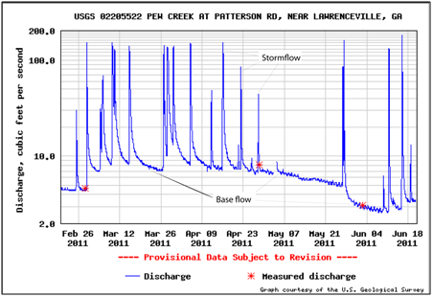
Figure 7: Streamflow hydrograph showing stormflow and baseflow components at Redland Creek near Lawrenceville, Georgia. This site is located near the ACF basin and demonstrates similar streamflow characteristics to ACF streams.
In addition to synoptic streamflow measurements, four sites will be equipped with continuous streamgages. Two of the sites will be from the high-density septic watersheds and two will be from the low-density septic watersheds. Pressure transducers will be installed at appropriate locations to measure stream stage and an appropriate rating will be established linking stream stage readings to stream discharge measurements taken over a range of flow conditions (high-medium-low).
Hydrograph separation will be conducted using continuous streamflow data and the computer program HYSEP (Sloto and Crouse, 1996), which systematically separates the base-flow and surface runoff components of a stream hydrograph by connecting low points on the hydrograph (Figure 8). Hydrograph separation provides the quantity of base-flow throughout the year, and can be expressed as a percentage of total mean-annual streamflow.
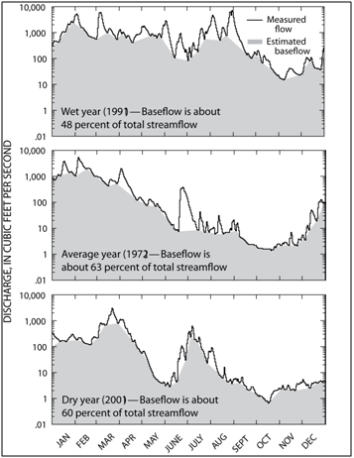
Figure 8: Streamflow hydrographs showing baseflow conditions during wet, dry, and normal conditions for a site on the Canoochee River near Claxton, Georgia (modified from Priest, 2004).

Task 7. Interbasin Transfers
Most interbasin transfers occur in the northern part of the ACF basin, where basins are long and narrow and public-supply systems extend over more than one basin. In several instances, public-supply systems withdraw water from one basin and discharge treated wastewater effluent into a different basin. To quantify this important part of the hydrologic budget for the ACF, available analysis of interbasin transfers will be incorporated into the SWUDS database.

Water Use Projections
Projections of future water use for the ACF basin have been developed by a number of State and local planning efforts, utilizing a variety of methods and assumptions for growth, climate, and other factors. Another factor affecting future water use in the basin is the recent Georgia Water Stewardship Act which mandates additional water-conservation measures in Georgia. The study area will assess the available water-use projections for the basin including any available for the Georgia Water Stewardship Act effects to determine the range of estimates and the assumptions underlying them. (See: http://www.caes.uga.edu/publications/pubdetail.cfm?pk_id=7908, accessed on 9/8/2011)

Surface-Water/Groundwater Interactions
To accomplish the goals of WaterSMART the SW/GW Interactions Team recommends model simulations of the ACF river system. The modeling of SW/GW flow for the ACF basin will be accomplished using two models. In general, surface-water flow will be simulated using the USGS Precipitation Runoff Modeling System (PRMS; Leavesley and others, 1983; Markstrom and others, 2008) and groundwater flow will be simulated using MODFLOW (Figure 1; Harbaugh, 2005). The only exception to this may be in the area simulated by MODLFOW, where the MODFLOW Stream Flow Routing (SFR) package will be used with PRMS providing simulations of net recharge only. The current modeling plan is to adapt and link previously developed models (both PRMS and MODFLOW) in the ACF. Surface-water flow will be simulated for the entire ACF basin; groundwater flow will be simulated only where the Floridan aquifer provides a significant portion of river discharge (Figure 1, Figure 3).
The two types of models will be calibrated for different, yet overlapping periods that will require a range of water withdrawal information. The groundwater model will be calibrated in a two-step process: the first step will be a steady-state calibration that will be used to establish the initial conditions for a transient calibration; in the second step the model will be calibrated to transient conditions. Groundwater level and streamflow data for 1999, 2001-2002, 2008, 2010, and 2011—years which have good information on irrigation withdrawal and synoptic measurements of hydrologic conditions will be evaluated, processed, and used to establish the conditions for the steady-state calibration. The transient model will be calibrated to either all or portions of the years: 2001-2002, 2008, 2010, and 2011. These years have both withdrawal data and synoptic measurements of streamflow and groundwater levels. The surface-water model will be calibrated for either all or portions of the years 2000, 2005, 2008, 2010, and 2011-the first two years having good information on surface-water withdrawal and some streamflow data, and the final three years having both withdrawal data and synoptic measurements of streamflow and groundwater levels.

PRMS

Current Conditions Climate Data
The PRMS models will use climate data from the National Oceanic and Atmospheric Administration (NOAA) Cooperative Observer Program (http://www.nws.noaa.gov/om/coop) as forcings for the model calibration period; this dataset is recommended in the WaterSMART Conceptual Plans for National Indicators and Ecological Flow Science. Maximum and minimum daily air temperature and daily precipitation totals are required to run PRMS models. PRMS simulates solar radiation (SR) and evapotranspiration (ET) in the absence of measured data. If measured SR and ET data are available for the basin and time period of interest, these can be used in the PRMS models as well.

Climate and Land Cover Projections
Global climate models (GCMs) have been downscaled to the NOAA climate stations through the year 2100 as part of the Southeast Regional Assessment Project (SERAP; http://serap.er.usgs.gov/). These data are being made available on the USGS GeoData Portal (http://cida.usgs.gov/projects.html). Projections of urbanization, vegetation, and water use will also be available in the basin and incorporated in simulations of projected water budgets.

Modeling in the ACF River Basin
PRMS is a deterministic, distributed-parameter, physical-process based hydrologic model. A suite of these hydrologic models was developed in the ACF River Basin using PRMS as part of the SERAP. A coarse resolution model of the entire basin (with spatial units averaging 200 km² or 77.2 mi²) and six fine resolution models (with spatial units averaging 1.5 – 2 km² or 0.58 – 0.77 mi²) in select sub-basins were developed to provide historical and projected streamflows in the ACF (Figure 1). These models were developed to provide natural flows throughout the basin.
The PRMS models were developed using several geographic information system (GIS) datasets including a 30 meter (98.5 feet) digital elevation model (DEM), the National Landcover Dataset 2001 (NLCD 2001), the STATSGO and SSURGO soils databases, maps of near-surface permeability compiled by Gleeson and others (2011), and hydrographs of USGS stream gages. These models were calibrated with Luca (Hay and Umemoto, 2006) which uses the Shuffled Complex Evolution (SCE; Duan and others, 1992, 1993, 1994) global search algorithm to optimize model parameters.
For WaterSMART, the existing coarse resolution model hydrologic response units (HRUs) will be refined to meet the HUC 12-digit spatial scale for reporting of Water budget components as directed by the WaterSMART Conceptual Plans for National Indicators and Ecological Flow Science. PRMS will initially be used to provide simulations of “baseline hydrographs” which are comparable to “natural/unimpaired” streamflows. Using these baseline hydrographs, the various sectors of water use (municipal, industrial, agricultural, etc.) will be incorporated in the models to provide simulations of actual streamflows throughout the Basin.

Task 1. PRMS module development
In order to better meet the goals of WaterSMART some additional modeling capabilities for PRMS can be developed at a modest cost. These new modeling capabilities will be available for use in future studies wherever PRMS is used. The module development is for accounting of gains/losses in the modeled basin.
There are many natural and anthropogenic processes, not accounted for in PRMS simulations, by which HRUs and stream segments can gain or lose water. These include consumptive use (for example irrigation, municipal, and industrial withdrawals), reservoir and canal operations, interbasin surface water transfers, deep groundwater flow, and interbed stream flow (for example gaining and loosing reaches). These processes must be accounted for when PRMS is calibrated or simulation results are otherwise compared to measurements at stream gages.
We propose to develop a new PRMS simulation module which will provide gain and loss capabilities with the simplest input requirements possible. New parameters would be hru_gain and seg_gain. These are two dimensional monthly parameters which specify a gaining flow rate for each HRU or stream segment, respectively. These parameter values could be positive (indicating a gain), negative (indicating a loss), or zero (the default value). Simulation of gains or losses from an HRU would occur as part of the soil zone simulation, and would be limited by soil water availability and capacity. Simulation of gains or losses from a stream segment would occur as part of the channel routing simulation, and would be limited by available stream flow. New output variables would include hru_actual_gain and seg_actual_gain. As it will be possible to affect the overall watershed water balance, there will be an aggregated version of this output variable basin_gain. A positive value of this variable will indicate that HRUs and stream segments are operating with a net gain.
This capability can be added to PRMS for a total cost of $15k. We estimate it will take a FORTRAN programmer one month to develop, debug, test, and document the “MonthlyGainLoss” module for PRMS.

Model calibration
The surface water model will initially be calibrated for natural flows to provide “baseline hydrographs” and then will be calibrated for a period of time including all or parts of the years 2000, 2005, 2008, 2010, and 2011-the first two years having good information on surface water withdrawal and some streamflow data, and the final three years having both withdrawal data and synoptic measurements of streamflow and groundwater levels. This calibration will use the same Luca software that was used to calibrate the original suite of ACF PRMS models during the SERAP.

Task 2. Calibrate the PRMS model for natural flows
The PRMS model will be calibrated for natural flows to provide “baseline conditions” for ACF streams as documented in the Conceptual Plan for WaterSMART.

Task 3. Link PRMS with MODFLOW
PRMS will be linked with MODFLOW in the lower part of the ACF basin to better simulate the water budget. PRMS will provide recharge data to the MODFLOW model.

Task 4. Incorporate water use
Water use will be incorporated into current and future simulations of streamflow throughout the ACF River Basin using data contained in the Site Specific Water Use Data System (SWUDS).

Task 5. Provide team members PRMS simulations streamflow conditions
Team members will be provided simulations of current streamflow conditions in the ACF basin outside of the MODFLOW domain.
Team members will be provided simulations of streamflow projections in the ACF basin outside of the MODFLOW domain.

Task 6. Document model development
The linking with MODFLOW and simulations of current and future streamflows throughout the ACF basin will be documented and published.

MODFLOW

Modeling in the Lower ACF Basin
Groundwater flow will be simulated using MODFLOW for the region shown on Figure 1 and Figure 3. A MODFLOW model was previously developed for this area and is currently in review. The Upper Floridan aquifer was simulated using 3 layers and the overlying surficial aquifer was simulated using 1 layer.
As mentioned earlier, the groundwater model will be calibrated in a two-step process: step 1 will be a steady-state calibration to establish the initial conditions for a transient calibration. The starting point for the modeling will be the steady-state model mentioned above; so this calibration will be a fine tuning/check on the model using more recently collected data. This data will be evaluated for periods when near steady-state conditions are occurring in the aquifer and the model calibrated to these. Typically they occur during dry periods when aquifer levels are changing slowly and surface waters have the highest percentage of groundwater.
In the second step, the model will be calibrated to transient conditions. The transient model will be calibrated to all or parts of the years 2001-2002, 2008, 2010, and 2011 because these years have both withdrawal data and synoptic measurements of streamflow and groundwater levels.

Calibration Procedure

Task 1. Develop MODFLOW input data sets for calibration
- The Water Use Team will compile metered irrigation water-use data from the Georgia Agricultural Water Conservation and Metering Program for 2007-2011, and will develop estimation techniques for areas and time periods not covered by this program. Public supply and industrial water use will be compiled for the same time period. These will need to be converted into time series data sets for MODFLOW to simulate transient pumping.
- Surface-water flow measurements and groundwater levels are available for 2008, 2010, and 2011, the latest period collected as part of WaterSMART. These data have been incorporated into the NWIS database and will need to be converted into data sets for MODFLOW calibration.
- Coordinate MODFLOW model and PRMS models grids to ensure that ecologically important areas are covered in sufficient detail.

Task 2. Calibrate a transient MODFLOW model
Calibrate model for all are parts of the years 2001-2002, 2008, 2010, and 2011 using MODFLOW-2005 and PEST. Estimates of transient recharge rates will come from the PRMS model and other sources.

Task 3. Calibrate MODLFOW using Stream Flow Routing (SFR) package
It is anticipated that MODLFOW will be initially calibrated using the river (RIV) package. However, after calibration (and non-changing aquifer properties such as hydraulic conductivities are set) then the SFR and/or Lake package(s) will be used.

Task 4. The MODFLOW and PRMS models will be combined using a “soft” link
The “soft” link means PRMS will provide simulated flows where the rivers enter the MODFLOW model area. In the MODFLOW SFR package, the simulated flows from PRMS will be treated as upstream inflows. MODFLOW will simulate gains/losses to the rivers to the downstream point where the rivers flow out of the model area. The flows at this point will be passed back to PRMS.

Climate Change Predictions

Task 5. PRMS predictions used to develop MODFLOW data sets
Use PRMS predictions for future net recharge rates to develop future net recharge data sets for MODFLOW. Future pumping will also be estimated.

Task 6. Run MODFLOW for prediction period and coordinate with PRMS model

Coordination with Environmental Flows Team

Task 7. Refine MODFLOW model grid around biologically sensitive areas
MODFLOW grid will be refined around biologically sensitive areas such as for Ichaway-Nochaway, Spring Creeks, or upper Chipola River basins for the future prediction period.
The refined model will be then used to simulate streamflows at selected locations and at time increments agreed upon with the Environmental Flows Team.

Meeting the Vision of the WaterSMART Conceptual Plans for National Indicators and Environmental Flow Science
In developing a workplan that would meet the goals of WaterSMART, the capabilities of the selected models were compared to the study needs addressed in the WaterSMART National Indicators and Ecological Flow Science Conceptual Plans.

National Indicators
- Delivering the Components of a Water Budget. PRMS uses daily inputs of precipitation and maximum/minimum temperature to compute the daily hydrologic response of a watershed. PRMS keeps track of the water budget inputs of precipitation, surface-water flow into the watershed, and groundwater flow into the watershed. PRMS also keeps track of water budget outputs of ET, changes in surface-water storage, snowpack storage, groundwater storage, and streamflow components in the forms of groundwater, surface runoff, and baseflow. Surface-water withdrawals and returns can be directly accounted for in PRMS. Effects of groundwater pumpage are not directly simulated by PRMS and will be handled through a coupling with the groundwater model MODFLOW.
- Spatial and temporal scale of the analysis. The conceptual plan for the spatial and temporal scales of WaterSMART calls for monthly water budget values at the HUC 12-digit scale. PRMS response units can be delineated in a variety of ways. By using the streamflow outlet of each HUC 12-digit to delineate PRMS hydrologic response units (HRUs), we can accomplish the spatial requirements of WaterSMART. PRMS simulates watersheds at a daily timestep. So, output from PRMS can be aggregated up to the appropriate temporal scale for the WaterSMART study. Once water use and other data become more readily available at smaller temporal scales, PRMS simulations will already be able to provide results at the required scale.
- Surface Water Indicators. For providing streamflow information in ungaged areas, PRMS is included in an additional WaterSMART study focused on the benefits of using various flow estimation methods, including both statistical and process based models. MODFLOW will be used to provide information on streamflow gains/losses due to groundwater interactions. StreamStats will be considered if time and funding allow.
- Precipitation and Evapotranspiration. PRMS will use the recommended data source of climate data from the National Weather Service. PRMS currently simulates Solar Radiation and Potential Evapotranspiration. However, if these inputs are available as measured data they can be read directly into the model simulation.
- Storage in Lakes, Reservoirs, Snowfields, and Glaciers. PRMS currently keeps track of the volume of snowpack in a watershed; however this is not typically an issue in the ACF basin. A module to simulate glaciers is currently in development, which will be useful in the Northwestern US and Alaska. A module to simulate lakes is currently available in PRMS; however this module simulates the lakes as run-of-the-river systems and does not incorporate rule curve type operations typical of large, managed reservoirs. PRMS also has a module extension developed by Viger and others (2010) which keeps track of the water volume stored in ‘small’ depression storages across the basin landscape. Of these various options, only the depression storage module extension is incorporated into the current PRMS models of the ACF basin. The MODFLOW Lake package can simulate changes in storage in lakes and can be used in areas simulated by MODFLOW.
- Human Water Use Indicators. The PRMS simulation of the ACF basin will include impacts of water use on streamflow as a part of the WaterSMART focus study. As the water use data will be available at a monthly timestep, PRMS will be integrated with the data at that temporal scale. The SWUDS will be the primary way of gathering water use information for the PRMS and MODFLOW simulations.
- On-Line Information Delivery and Analysis Tool. PRMS simulations will provide appropriate water budget information for delivery and analysis in the online application developed as a part of WaterSMART; as will MODFLOW simulations.

Environmental Flow Science
- Role of Environmental Flow Science in the Water Census. With the steps proposed in WaterSMART of (1) building a national hydrologic foundation of baseline hydrographs or hydrologic statistics for all ungaged streams and (2) deriving and serving a set of ecologically-relevant flow attributes that can be used to classify streams into distinctive regional and national flow regime types, PRMS simulations of the ACF basin readily provide the streamflow information for these kinds of analyses.
- Baseline hydrographs. PRMS can provide simulated hydrographs with or without water use incorporated for any HRU and any stream segment in the model. The addition of a soft link between PRMS and MODFLOW will improve these simulated hydrographs in the lower ACF basin.
- A National Classification of Streams into Hydroecological Types. PRMS baseline hydrographs and water use impacted hydrographs can be used where there is not sufficient measured streamflow data to characterize streams with various characteristics.
- Defining Flow – Ecological Response Relationships. Simulated streamflows are a necessary part of defining this relationship where there is not sufficient measured streamflow data. If the ecological relationships are based on flows at the confluence to confluence level, a single value of discharge at a basin outlet is not sufficient and a way of obtaining those incremental flows may be through a model simulation. Future flow alteration can be simulated using PRMS with downscaled climate data and projections of land cover and water use. MODFLOW can simulate the groundwater contribution to streamflow, at a variety of scales, and in stream reaches that are not gaged.
The SW/GW Interactions Team has the capacity to output many different parts of the water budget at various temporal scales. If, in the future, it is found that additional tasks or projects can use the simulated results (e.g. – an Apalachicola Bay salinity model, a water temperature model, a reservoir management model, or a water-quality model), these data needs can be addressed at that time.

Environmental Flows
Specifying the water needs of freshwater ecosystems is a task complicated by the natural temporal and spatial variability of hydrologic regimes. For example, streams typically experience a wide range of flow conditions, from drought-associated low flows, to higher flows during “wet years”, to periodic flooding. The effects of a given level of streamflow on many ecological processes may also vary depending on factors such as watershed size, channel shape and sediment characteristics, and traits of the species composing the biological community. In recognition of the importance of natural variability to ecological function, ecologists have turned the question of how much streamflow is needed to sustain freshwater ecosystems? to asking instead how much can streamflow regimes be altered before causing unacceptable ecological change? (Annear and others, 2004; Arthington and others, 2006). Ecologists further recognize that the answers are likely to differ depending on the geomorphic and hydrological context of a given stream system (Poff and others, 2006; Peterson and others, 2009b; McCargo and Peterson 2010).
In a synthesis of these ideas, and recognizing the need for identifying environmental flows across large spatial extents where limited resources preclude evaluation of individual river systems (Arthington and others, 2006), ecologists recently outlined an approach called the Ecological Limits of Hydrologic Alteration (ELOHA; Poff and others, 2010). The ELOHA framework is a systematic and flexible approach for assessing and managing environmental flows, and is intended to accelerate the integration of environmental flows into regional water resource planning, management, and decision-making (Conservation Commons; http://conserveonline.org/workspaces/eloha). There are four basic steps in the science component of the ELOHA approach (Figure 9):
- Building a hydrologic foundation of streamflow hydrographs representing baseline (“natural” or pre-development) and present-day conditions, for locations where ecological conditions can be assessed (“analysis nodes”).
- Defining river types according to hydrologic characteristics and other criteria, such as geomorphic context.
- Assessing streamflow alteration at analysis nodes by comparing frequency distributions of specified flow variables (e.g., the annual 10-day minimum flow) for baseline with present-day hydrographs.
- Developing flow alteration – ecological response curves using measures of hydrologic change and ecological conditions at the analysis nodes, for the differing river types specified in the second step. Ideally, analysis nodes will include locations representing a range of levels of streamflow alteration (i.e., from near “natural” to highly modified), for each river type.
Implementation of the ELOHA approach is achieved by a consensus process that engages stakeholders and water managers, informed of the flow-ecology relationships, in establishing policies and adaptive strategies for maintaining and/or restoring environmental flows. The basis of implementing ELOHA in any given setting is to evaluate acceptable risk as a balance of perceived values of ecological goals with socioeconomic costs, given scientific uncertainties in functional relationships between ecological responses and flow alterations (Poff and others, 2010).
A critical step in the ELOHA approach is the development of robust quantitative relations between indicators of ecological condition and gradients of hydrologic alteration, for each stream class of interest. Numerous studies illustrate correlations between streamflow alteration and the composition of biological communities in streams and rivers (Roy and others, 2005; Freeman and Marcinek, 2006; Kanno and Vokoun, 2010; Kennen and others, 2010; Spooner and others, 2011; Merritt and Poff, 2010). However, plots of flow-ecology relations using data across large regions often show substantial unexplained variation (see, e.g., Konrad and others, 2008; Knight and others, 2008). In fact, a recent analysis of 165 published studies concludes that although these studies support the hypothesis that ecological change increases with degree of streamflow alteration, results among existing studies are too variable to support development of general, broadly applicable flow-ecology relations (Poff and Zimmerman, 2010). High variability in empirical datasets is not unexpected, because multiple factors in addition to streamflow regime may influence species occurrences and abundances at a particular stream location, at any given point in time. Nonetheless, high variability may often confound precise measurement of the effects of hydrologic change on stream biota, adding uncertainty to ELOHA-type processes (Poff and others, 2010).
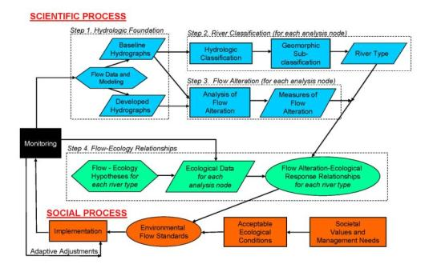
Figure 9: Flow chart for evaluating the Ecological Limits of Hydrologic Alteration (ELOHA) (from: Conservation Commons; http://conserveonline.org).

Advancing Environmental Flow Science
In this project, we propose to further develop a complementary approach for relating flow alteration to stream biota, in support of ELOHA and similar (Zorn and others, 2008) applications. Specifically, we will build on recent research in the ACF basin that combines measured effects of streamflow variability on selected biological processes (survival, reproduction and colonization) that drive population dynamics in stream ecosystems, with modeled hydrology in order to simulate ecological responses to streamflow changes (Peterson and others, 2011; Peterson and others, in preparation; Freeman and others, in review). Key in this approach is the ability to evaluate support for alternative hypotheses about effects of high and low streamflows, or of stable streamflows compared to variable streamflows, on stream biota. Additionally, we will collect field data to improve understanding of how (1) stream system fragmentation and (2) water-quality variation modify ecological responses to streamflow change. Prototype metapopulation models for stream fishes show high sensitivity to assumptions regarding potential for fish to disperse, highlighting an area where research can reduce model uncertainty. Integrating water quality with analyses of effects of hydrologic alteration on stream biota also is an area where research is needed to improve assessment and forecasting capabilities (Nilsson and Renofalt, 2008).
Similar to the ELOHA framework, the approach we will apply requires a hydrologic model capable of simulating streamflow dynamics throughout the segments composing the stream system of interest. Empirical data are also needed, but in this approach, the data relate temporal changes in species abundances (for population models, as in Peterson and others, 2011) or occurrences (for metapopulation models, as in Shea, 2011; Freeman and others, in review) to segment-specific streamflow variation, rather than relating static descriptions of biological condition to long-term streamflow metrics. Combining modeled hydrologic time series with field measurements of population or metapopulation responses allows for dynamic simulations of changes in biological condition across the stream system in response to management or climate scenarios. Uncertainty in how species will respond to hydrologic change (i.e., because data support alternative hypotheses concerning streamflow effects on biological processes) can be examined explicitly by comparing projected outcomes for alternative assumed flow-ecology mechanisms. Effects of uncertainty in model parameters on projected outcomes can also be quantified in simulations.

Work Tasks
The hydrologic foundation and stream classification steps specified in the ELOHA process are being completed for the ACF as part of the SERAP project. The hydrologic foundation component presently comprises basin-wide surface-water runoff projections at a daily timestep for “natural flow” conditions, at a relatively coarse spatial resolution. Additionally, stream-segment scale (“fine-resolution”), daily timestep natural flow simulations have been developed for six sub-basins within the ACF. The Water Use and SW/GW Interactions components of the ACF WaterSMART project will develop the data and hydrologic models necessary to simulate current and future streamflow conditions. This will include daily timestep flows for the six sub-basins with fine-resolution hydrologic models, which will be used to estimate streamflow variables hypothesized to influence biological processes. Streams in the ACF have also been classified on the basis of geomorphic variation as part of the SERAP project. The following tasks fall under the development of “flow-ecology response curves” component of ELOHA, entailing data collection, hypothesis evaluation, and simulation of flow alteration effects on species distributions and/or abundances.

Task 1. Sample native freshwater mussels and fishes
Sample native freshwater mussels and fishes in conjunction with previous and ongoing studies at selected sites within the ACF basin, and at newly selected sites. Ecological studies will focus on native freshwater mussels and fishes in wadeable streams, because these taxa are sensitive to changes in hydrology and are the focus of prior and ongoing intensive studies in the ACF basin. Sites will be selected in ACF sub-basins where fine-resolution hydrologic models are being developed as part of SERAP (Figure 10) or near USGS gages, so that hydrologic time series can be generated and used to model observed changes in species occurrences or abundances.
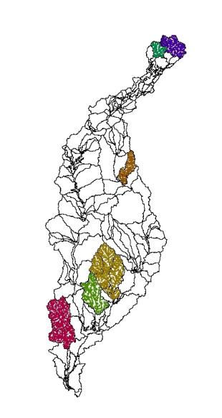
Figure 10: ACF basin outline showing hydrologic response units for a basin-wide model of surface flows, and stream networks for six sub-basins where fine-resolution, “unimpaired flow” models have been developed as part of SERAP, and where biological sampling efforts will focus. Sub-basins are, from headwaters to downstream: upper Chattahoochee R., Chestatee R., Potato Cr., Ichawaynochaway Cr., Spring Cr., and Chipola R.
Sampling will be designed to estimate changes in species-status (abundances and/or occurrences; depending on taxa, and study basin) in relation to streamflow dynamics, and will account for incomplete detection. Sampling to track annual changes in abundances of selected fishes and mussels in Chipola River and Spring Creek systems will occur in late summer to fall when adults and recruits of most fish and mussels are detectable and stream levels permit efficient capture. For measuring fish metapopulation dynamics, sites in Ichawaynochaway Creek, Potato Creek and the upper Chattahoochee/Chestatee River systems will be sampled twice a year, in spring and late summer/early fall. Dual sampling approaches will allow us to build on prototype metapopulation models developed in the Science Thrust and SERAP efforts (Peterson and others, in prep; Freeman and others, in review), while adding a finer component of measuring population changes in response to streamflow dynamics (Peterson and others, 2011). Fish sampling will be accomplished by using backpack, tote-barge, and/or boat-mounted electrofishing units, in depletion sampling methods or in replicated block-netted units, encompassing the suite of habitats encountered. All fish will be identified to species and counted within size ranges. Any fish where identification requires laboratory examination will be anesthetized with MS222 prior to preservation in 10% formalin. Fish and mussel sampling has already started in Ichawaynochaway Creek, Potato Creek, and Spring Creek systems; additional sites will be added in the Chipola, Chestatee, and Upper Chattahoochee river systems in 2012. Depending on site availability, it is anticipated that 8-15 sites will be sampled, each in the Blue Ridge, Piedmont and Coastal Plain physiographic regions for fish metapopulation dynamics. Additional Coastal Plain sites will be sampled annually to track fish and mussel population dynamics.
Mussel sampling will focus on mark-recapture methods using visual/tactile surveys and suction-dredge quadrats in the Spring Creek and Chipola River systems. Spring Creek is a former tributary of the Flint River, but now flows directly into Lake Seminole. Spring Creek has a history of declining flows due to groundwater pumping by center pivot irrigation on agricultural lands. Increasing demands on surface waters and the regional aquifer system appear to be contributing to declines in mussel populations (Golladay and others, 2004). The State of Georgia recently (summer 2011) installed a well to augment flows in the mainstem of Spring Creek to help protect downstream fish and mussel populations. Freshwater mussel populations in Spring Creek have received research attention by Stephen Golladay (Jones Ecological Research Station), Sandy Abbott (US Fish and Wildlife Service, Ft. Benning Office), and Jason Wisniewski (Georgia Department of Natural Resources). The Environmental Flows Team research efforts aim to utilize previous findings and complement ongoing studies. The Chipola River is a tributary of the Apalachicola River that has its headwaters near Dothan, AL and flows south into the Apalachicola River via the Dead Lakes. Multiple impoundments of various sizes are found in the headwaters and some evidence of nutrient enrichment has been documented. Similar to Spring Creek, the Chipola River is dominated by groundwater flows with many springs but appears less affected by withdrawals for agricultural purposes. Outputs from existing fine-resolution surface-water models for the Spring Creek and Chipola River systems will be used to select sampling sites where fish and mussel community structure and population demographics will be evaluated on a yearly basis for the next three years.

Task 2. Sample water quality at a subset of sites
Water-quality data will be collected concurrently with biota sampling and used to evaluate relations among water-quality parameters and the distribution of fish species. Specifically, variation in water-quality measurements among sites will be evaluated as potential covariates in regression models relating observed, site-specific changes in species status to flow variables. To obtain the necessary data, physicochemical parameters consisting of pH, conductivity, dissolved oxygen, and temperature will be measured at all sites during biological sampling. Due to limited resources, collection of water-quality samples for chemical analysis will be limited to selected sites. Approximately 24 sites will be sampled twice a year over the two years of the project. Three of the six watersheds selected for biological sampling will be sampled for water quality, one in each of the three physiographic provinces (Blue Ridge, Piedmont, and Coastal Plain). Sites will be selected based on major land-use types within the watersheds to characterize the range of expected water-quality conditions. The water-quality samples will be collected using standard USGS protocols and analyzed for nutrients and major ions at the USGS National Water-Quality Lab.
Continuous water-quality data will be collected at six sites to obtain a better understanding of temporal variability. Probes will be deployed in headwater streams and at outlets of the major basins sampled for water quality. Temperature and conductivity will be measured at 15-minute intervals and will provide a better understanding of how synoptic samples fit into the broader context of longer-term water-quality conditions. Data will be collected for the first two years of the study. Funds are requested for the last year of the study to analyze data and write a report.

Task 3. Update existing biological models
Update existing models relating population and metapopulation responses to streamflow metrics using newly collected data and tests for water-quality effects on flow-ecology relations. Data analysis will entail using hierarchical regression to relate changes in species abundances or occurrences at sampled locations, to seasonal flow metrics for each interval between samples. Covariates in candidate models will include stream classes (e.g., size, channel confinement), water-quality variables, and species traits for selected taxa. Candidate models will be based on a priori hypotheses relating streamflow and water-quality metrics to fish and mussel responses.

Task 4. Apply models to predict biological change
Apply best-supported models to forecast changes in status of select fishes and mussels under climate and management scenarios. Daily time series of streamflows will be simulated with fine-resolution hydrologic models for current conditions and a set of climate and management scenarios (of interest to stakeholders) for each of the sub-basins. Seasonal flow metrics will be calculated for alternative scenarios at annual time steps, and used to simulate population responses for fish and mussel species of interest, using updated and best-supported population or metapopulation models. Results of simulations may be summarized as changes in species occupancy rates, changes in species richness, relative abundances, or in the case in population models, changes in probability of extinction over the simulated time period.

Task 5. Develop flow-ecological response curves
Best-supported regression models will be used in spatially-explicit simulations of population state dynamics for streamflow scenarios applied to sub-basins Blue Ridge, Piedmont and Coastal Plain. Streamflow scenarios may include hypothetical, plausible, changes in streamflow characteristics, to produce a series of flow-metapopulation response curves for differing types of species and differing physiographic regions (see example in Figure 11).
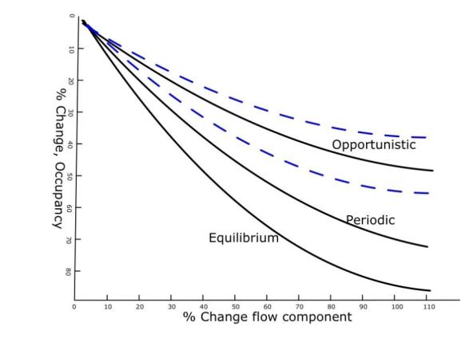
Figure 11: Hypothetical flow-ecology response curves, showing percent decrease in fish species occupancy versus percent change in a streamflow component, for fish species with three life-history strategies. Blue lines represent hypothetical limits of uncertainty for opportunistic species, for illustration. Similar curves could be simulated for streams with differing characteristics (e.g., small vs. large streams, confined vs. unconfined, physiography or water quality classes), depending on the strength of evidence that these covariates modify species responses.

INFORMATION INTERCHANGE AND COMMUNICATIONS

Technical Team Interchange across Water Use, Surface-Water/Groundwater Interactions, and Environmental Flows
Although there are three Teams working simultaneously on different technical aspects of WaterSMART in the ACF basin, the work of each team is closely related. The Water Use Team has to provide information to the SW/GW Interactions Team for their numerical models. It is necessary for both teams to work closely to develop a water budget, as well as provide streamflow information to the Environmental Flows Teams. It is critical that the data and output produced by each team are formatted in a manner that can be utilized by other teams.
Timely data and information exchange will occur throughout the length of the project. Monthly conference calls and quarterly meetings will be scheduled for the Teams to provide progress updates and open up for question and answers. Written progress reports will be provided annually. In addition to the formal calls and meetings, each scientist will be communicating one-on-one with others to assure that data needs are being met according to objectives of each team.

Products and Deliverables

Water Use
A variety of databases and publications will be prepared as part of the water use component of WaterSMART for the ACF basin. Proposed publications include:
- National 5-year water use report, prepared independently of WaterSMART
- Journal article detailing the identification of irrigated lands and estimation of agricultural water use via remote sensing
- Report or journal article to compare and contrast methods application across ACF and Yazoo Delta study areas
- Report describing methods to estimate irrigation withdrawal using crop demand and climate data
- Report or journal article to compare and contrast methods to estimate irrigation withdrawal in ACF basin
- Report describing influence of septic systems on consumptive use
- Report describing withdrawals, return flows, and interbasin transfers from municipal and industrial sources, and water use projections in the ACF basin

Surface-Water/Groundwater Interactions
A USGS Scientific Investigations Report (SIR) will be written documenting the simulation of the ACF River Basin using the soft linked PRMS and MODFLOW models. This report will document the simulation of current and projected water budgets in the ACF basin.

Environmental Flows
The primary products of this research will be an improved understanding of how stream fishes and mussels respond to streamflow variability, and illustrations of how that understanding can be used to assess and forecast ecological outcomes for future scenarios of water availability and use. Specific products will include:
- Report documenting procedures used for study and describing improvements in capability to predict occupancy models for fish and mussels species.
- Report describing empirical support for hypotheses relating streamflow and water quality metrics to fish and mussel population or metapopulation dynamics, including tests for differences among streams in Blue Ridge, Piedmont and Coastal Plain physiographic provinces.
- Example flow-ecology response curves, derived from sub-basin scale simulations of changes in species occupancy with changes in streamflow conditions.

TIMELINES
Table 1: Timeline for Water Use Team; * = date of 11/18/2011; ** = date of 06/04/2012
 | FY11 | FY 12 |  |  |  | FY 13 |  |  |  | FY 14
Water Use | Q4 | Q1 | Q2 | Q3 | Q4 | Q1 | Q2 | Q3 | Q4 | Q1 | Q2 | Q3 | Q4
Compile withdrawal data 1999-2011 | X | X | X | X | X | X | X | X | X | X | X | X
Non-Irrigation | X | X | X | X
Compile and Estimate Data | X | X
Report Review and Approval |  |  | X | X
Irrigation | X | X | X | X | X | X | X | X | X | X | X | X
Acquire GaMP Data & Establish SWUDS  Sites | X
Estimate Irrigation from Remote Sensing | X | X | X | X | X | X | X | X | X | X | X | X
USDA Database acquisition/processing | X
Satellite Database Development |  | X
Modeling Software Implementation |  |  | X
Latent Heat/ET Modeling |  |  |  | X
Statistical Model Development |  |  |  |  | X
Irrigated Lands Modeling and Assessment |  |  |  |  |  | X
Estimate Total Water Use |  |  |  |  |  |  | X
Analysis, Report Preparation, Review,  and Approval |  |  |  |  |  |  | X | X | X | X | X | X
Estimate Irrigation from Crop Demand | X | X | X | X | X | X | X | X | X | X | X | X
Prepare Input Files/GIS Layers | X | X
Calculate Crop ET, Ref. Crop ET, and  Effective Flux |  |  | X | X
Compare Estimates to Metered Data |  |  |  |  | X | X
Analysis, Report Preparation, Review,  and Approval |  |  |  |  |  |  | X | X | X | X | X | X
Return Flows Septic | X | X | X | X | X | X | X | X | X
Compile GIS Layers (septic systems, land use,  etc…) | X
Install Stream Gages | X
Conduct Fall Synoptic Streamflow Run |  | X*
Conduct Spring Synoptic Streamflow Run |  |  | X**
Hydsep Analysis |  |  |  |  | X
Analysis, Report Preparation, Review, and  Approval |  |  |  |  |  | X | X | X | X
Return Flows M & I |  |  |  |  | X | X | X
Compile Available NPDS Data |  |  |  |  | X
Estimate Losses from M & I Withdrawal |  |  |  |  |  | X | X
Interbasin Transfers |  |  |  |  |  |  | X | X | X
Compile Available Information on Transfers |  |  |  |  |  |  | X
Develop SWUDS Model Showing Transfers |  |  |  |  |  |  |  | X | X
Determine Projected Water Use |  |  |  |  |  |  |  |  | X | X
Analysis, Report Preparation, Review, and Approval |  |  |  |  |  |  |  |  |  | X | X | X

Table 2: Timeline for Surface Water/Groundwater Interactions Team
 | FY11 | FY 12 |  |  |  | FY 13 |  |  |  | FY 14
Surface-Water/Groundwater Modeling | Q4 | Q1 | Q2 | Q3 | Q4 | Q1 | Q2 | Q3 | Q4 | Q1 | Q2 | Q3 | Q4
PRMS –Setup and Calibration Procedure
Task 1 (PRMS) Refine PRMS model to HUC 12-digit spatial scale |  | X | X
Task 2 (PRMS) Develop PRMS MonthlyGainLoss Module |  |  | X
Task 3 (PRMS) Calibrate PRMS model for natural flows (baseline conditions) |  |  | X | X | X | X
Task 4 (PRMS) Link PRMS with MODFLOW for lower ACF |  |  |  | X | X | X | X | X
Task 5 (PRMS) Incorporate water use data from SWUDS into PRMS model |  |  |  |  | X | X | X | X
Task 6 (PRMS) Provide current conditions results to team |  |  |  |  |  | X | X | X | X
PRMS –Climate Change Predictions
Task 7 (PRMS) Simulate future projections and provide results to team |  |  |  |  |  |  | X | X | X | X
Products
Task 8: Write a report describing modeling and results. |  |  |  |  |  | X | X | X | X | X | X | X | X
MODFLOW –Calibration Procedure
Task 1a: Convert Georgia Agricultural Water Conservation and Metering Program data into time series data sets for MODFLOW to simulate transient pumping. |  |  | X | X | X | X | X | X | X
Task 1b: Convert surface water flow and groundwater levels being collected for WaterSMART into data sets for MODFLOW calibration. |  | X | X | X | X | X | X | X | X
Task 1c: Coordinate MODFLOW model grid size and cell spacing with PRMS and ecologists. |  | X | X | X | X
Task 2: Calibrate a steady-state MODFLOW model for the period leading up to 2007. |  |  |  | X | X | X | X | X | X | X | X
Task 3: Convert the MODFLOW steady-state model to a transient model and calibrate to the period 2007 to 2011. |  |  |  |  | X | X | X | X | X | X | X
Task 4: MODFLOW and PRMS models will be combined using a “soft” link. |  |  |  | X | X | X | X | X | X | X | X
Task 5: Use PRMS predictions for future net recharge rates to develop data sets for MODFLOW; incorporate future pumping predictions. |  |  |  |  | X | X | X | X | X | X | X
Task 6: Run MOFLOW for future prediction period and coordinate with PRMS model. |  |  |  |  | X | X | X | X | X | X | X
MODFLOW –Coordination with Environmental Flow Research Team
Task 7: Refine MODFLOW calibration around biologically sensitive areas. |  |  |  |  |  |  |  | X | X | X | X
Products
Task 8: Write a report describing modeling and results. |  |  |  |  |  | X | X | X | X | X | X | X | X
Task 9: Archive data as tasks are finished. |  |  |  |  |  | X | X | X | X | X | X | X | X

Table 3: Timeline for Environmental Flows Team
 | FY11 | FY 12 |  |  |  | FY 13 |  |  |  | FY 14
Environmental Flows | Q4 | Q1 | Q2 | Q3 | Q4 | Q1 | Q2 | Q3 | Q4 | Q1 | Q2 | Q3 | Q4
Study plan preparation | X
Selection of new ecological sampling sites | X | X
Reconnaissance of new ecological sampling sites to map habitat, test sampling gears, collect preliminary data |  | X | X
Intensive annual mussel and fish sampling (open late summer/fall window contingent on hydrologic conditions). |  |  |  | X | X |  |  | X | X |  |  | X | X
Seasonal sampling to track fish metapopulation dynamics in relation to flow, in contrasting physiographic and water quality contexts (spring and late summer/fall) |  |  |  | X | X | X |  | X | X | X |  | X | X
Water quality sampling in conjunction with seasonal samples. |  |  |  | X | X | X |  | X | X | X |  | X | X
Data analysis and model updating |  |  |  |  |  | X |  |  |  | X
Simulations of fish and mussel responses to streamflow dynamics using “current condition” flows model developed from water use and surface – groundwater interaction components of WaterSMART |  |  |  |  |  |  |  |  | X | X | X | X | X
Interim reports |  |  |  |  | X |  |  |  | X
Draft final report |  |  |  |  |  |  |  |  |  |  |  |  | X

BUDGET
 | FY2012 | FY2013 | FY2014
Water Use
Non-Irrigation Use1 | $15,848 | $0 | $0
Irrigation | $46,000 | $31,000 | $20,000
Irrigation | $75,277 | $74,500 | $16,400
Septic | $53,127 | $49,623 | $0
M&I returns | $0 | $36,599 | $6,598
Interbasin transfers and use projections | $0 | $0 | $60,663
PRMS Surface Water Flow Modeling
Development of PRMS Model of Whole ACF River Basin and Linking with MODFLOW in Lower ACF Basin | $76,670 | $148,360 | $143,280
Travel | $1,500 | $1,500 | $1,500
Development of PRMS Module to Use in Put From Groundwater Model for Gains/Losses | $15,000
SIR Report |  |  | $50,000
Fact Sheet |  |  | $15,000
MODFLOW Groundwater Flow Modeling
Development of MODFLOW Model of Lower ACF River Basin and Linking with PRMS | $183,304 | $181,064 | $174,272
Travel | $2,000 | $2,000 | $2,000
TOTAL | $468,726 | $524,646 | $489,713
Environmental Flows: Fish and mussel population dynamics assessments
Chipola, Spring (fishes and mussels) and Ichawayanochaway (mussels) systems – SESC | $60,000 | $60,000 | $60,000
Upper Chattahoohcee/Chestatee, Potato, Ichawaynochaway (fishes) systems - PWRC/University contract | $60,000 | $60,000 | $60,000
Data analysis and model updating, simulations | $39,000 | $39,000 | $19,000
Report preparation | $6,000 | $6,000 | $26,000
Assessments | $35,000 | $35,000 | $35,000
TOTAL | $200,000 | $200,000 | $200,000
Water quality assessments:
Collection and analyses of water samples | $60,000 | $60,000 | $30,000
Collection of continuous specific conductance data | $13,500 | $10,000
TOTAL | $73,500 | $70,000 | $30,000
TOTALS - ALL WORK | $742,226 | $794,646 | $719,713

REFERENCES AND RESOURCES
Allen, R.G., Periera, L.S., Raes, D., Smith, M., 1998. Crop evapotranspiration: Guidelines for computing crop requirements. Irrigation and Drainage Paper No. 56, FAO, Rome, Italy, 300 pp.
Allen, R.G., Tasumi, T., Morse, A. and Trezza, R. 2005. A landsat-based energy balance and evapotranspiration model in western US water rights regulation and planning. Journal of Irrigation and Grainage Sstems, 19: 355-376.
Annear, T. and 15 others. 2004. Instream Flows for Riverine Resource Stewardship, Second edition. Instream Flow Council.
Archfield, S. A., and R. M. Vogel (2010), Map correlation method: Selection of a reference streamgage to estimate daily streamflow at ungauged catchments, Water Resour. Res., 46, W10513, doi:10.1029/2009WR008481.
Archfield, S.A., R.M. Vogel, P.A. Steeves, S.B. Brandt, P.K. Weiskel, and S.P. Garabedian, (2010), The Massachusetts Sustainable-Yield Estimator: A decision-support tool to assess water availability at ungaged sites in Massachusetts, U.S. Geological Survey Scientific Investigations Report 2009-5227, 41 p., plus CD–ROM.
Arthington, A.H., S.E. Bunn, N.L. Poff and R.J. Naiman. 2006. The challenge of providing environmental flow rules to sustain river ecosystems. Ecological Applications 16(4):1311-1318.
Bastiaanseen, W.G.M., Menenti, M., Feddes. R.A. and Holtslag, A.A.M., 1998a. A remote sensing surface energy balance algorithm for land (SEBAL): 1. Formulation. Journal of Hydrology, 212-212: 198-212.
Bush, P.W., and Johnston, R.H., 1988, Ground-water hydraulics, regional flow, and ground-water development of the Floridan aquifer system in Florida and parts of Georgia, South Carolina, and Alabama: U.S. Geological Survey Professional Paper 1403-C, 80 p.
Dalton, M.S. and S.A. Jones. 2010. Southeast Regional Assessment Project for the National Climate Change and Wildlife Science Center, U.S. Geological Survey. USGS Open-File Report 2010-1213.
Draper, S.L., 2005, Sharing water through interbasin transfer and basin of origin protection in Georgia: issues for evaluation in comprehensive state water planning for Georgia’s surface water rivers and groundwater aquifers: Georgia State University Law Review, vol. 21:339, p. 339-372.
Duan, Q.Y., Gupta, V.K., and Sorooshian, S., 1993, Shuffled complex evolution approach for effective and efficient global minimization: Journal of Optimization Theory and Applications, v. 76, no. 3, p. 501–521.
Duan, Q.Y., Sorooshian, S., and Gupta, V., 1992, Effective and efficient global optimization for conceptual rainfall-runoff models: Water Resources Research, v. 28, no. 4, p. 1015–1031.
Duan, Q.Y., Sorooshian, S., and Gupta, V.K., 1994, Optimal use of the SCE-UA Global Optimization Method for calibrating watershed models: Journal of Hydrology, v. 158, no. 3–4, p. 265–284.
Fanning, J.L., 2007, Consumptive water use—a critical component of Georgia’s comprehensive statewide water-management plan: in Proceedings of the 2007 Georgia Water Resources Conference, held March 27–29, 2007, at The University of Georgia, Athens, Georgia. http://www.gwri.gatech.edu/conferences/previous-gwrc-conferences/gwrc-2007/
Freeman, M.C., G.R. Buell, L.E. Hay, W.B. Hughes, R.B. Jacobson, J.W. Jones, S.A. Jones, J.H. LaFontaine, K.R. Odom, J.T. Peterson, J.W. Riley, J.S. Schindler, C.Shea, J.D. Weaver. In review. Linking river management to freshwater conservation using dynamic landscape-scale models. Manuscript.
Freeman, M. C. and P. A. Marcinek. 2006. Fish assemblage responses to water withdrawals and water supply reservoirs in Piedmont streams. Environmental Management 38: 435-450.
Gleeson, T., Smith, L., Moosdorf, N., Hartmann, J., Durr, H.H., Manning, A.H., van Beek, L.P.H., and Jellinek, A.M., 2011, Mapping permeability over the surface of the Earth: Geophysical Research Letters, v. 38, L. 02401, 6 p.
Golladay, S. W., Gagnon, P., Kearns, M., Battle, J. M., and Hicks, D. W. 2004. Response of freshwater mussel assemblages (Bivalvia:Unionidae) to a record drought in the Gulf Coastal Plain of southwestern Georgia. Journal of the North American Benthological Society, 23(3), 494-506.
Gordon, D.W., and Peck, M.F., 2010, Stream base flow and potentiometric surface of the Upper Floridan aquifer in south-Central and southwestern Georgia, November 2008: U.S. Geological Survey Scientific Investigations Report 2010–5095, 22 p. http://pubs.usgs.gov/sir/2010/5095/
Gregory, M. B., M. C. Freeman and W. B. Hughes. 2006. Water Availability for Ecological Needs in the Upper Flint River Basin, Georgia. USGS Fact Sheet 2006-3114.
Harbaugh, A.W., 2005, MODFLOW-2005, The U.S. Geological Survey modular ground-water model – the ground-water flow process: U.S. Geological Survey Techniques and Methods 6-A16, variously paginated.
Hay, L.E., and Umemoto, M., 2006, Multiple-objective stepwise calibration using Luca: U.S. Geological Survey Open-File Report 2006-1323, 28 p.
Hay, L.E, G.H. Leavesley, M.P. Clark, S. L. Markstrom, R. J. Viger, and M. Umemoto (2006), Step-wise, multiple objective calibration of a hydrologic model for a snowmelt-dominated basin. J. Amer. Water Resour., 42, 877–890.
Hughes, W.B., Freeman, M.C., Gregory, M.B., and Peterson, J.T., 2007, Water availability for ecological needs in the Upper Flint River Basin, Georgia-A USGS Science Thrust Project, in Rasmussen, T., Carroll, G.D., and Georgakakos, A., Proceedings of the 2007 Georgia Water Resources Conference, Athens, Georgia, March 27-29, 2007: The University of Georgia, Center for Continuing Education, 3 p.
Hutson, S.S., Barber, N.L., Kenny, J.F., Linsey, K.S., Lumia, D.S., and Maupin, M.A., 2004, Estimated use of water in the United States in 2000: U.S. Geological Survey Circular 1268, 46 p.
Jelks, H.L., S.J. Walsh, N.M. Burkhead, S. Contreras-Balderas, E. Diaz-Pardo, D.A. Hendrickson, J. Lyons, N.E. Mandrak, F. McCormick, J.S. Nelson, S.P. Platania, B.A. Porter, C.B. Renaud, J.J. Schmitter-Soto, E.B. Taylor and M.L. Warren, Jr. Conservation status of imperiled North American freshwater and diadromous fishes. 2008. Fisheries 33(8):372-407.
Jones, L.E., and, Torak, L.J., 2006, Simulated efects of seasonal ground-water pumpage for irrigation on hydrologic conditions in the lower Apalachicola–Chattahoochee–Flint River Basin, southwestern Georgia and parts of Alabama and Florida, 1999–2002: U.S. Geological Survey Scientific Investigations Report 2006-5234, 83 p., a Web-only publication at http://pubs.usgs.gov/sir/2006/5234/.
Kanno, Y. and J. C. Vokoun. 2010. Evaluating effects of water withdrawals and impoundments on fish assemblages in southern New England streams, USA. Fisheries Management and Ecology 17: 272-283.
Kennen JG, Riva-Murray K, Beaulieu KM. 2010. Determining hydrologic factors that influence stream macroinvertebrate assemblages in the northeastern U.S. Ecohydrology 3: 88-106.
Knight, R. R., M. B. Gregory and A. K. Wales. 2008. Relating streamflow characteristics to specialized insectivores in the Tennessee River Valley: a regional approach. Ecohydrology 1: 394-407.
Konrad, C. P., A. M. D. Brasher and J. T. May. 2008. Assessing streamflow characteristics as limiting factors on benthic invertebrate assemblages in streams across the western United States. Freshwater Biology 53: 1983-1998.
Landers, M.N., and Ankcorn, P.D., 2008, Methods to evaluate influence of onsite septic wastewater-treatment systems on base flow in selected watersheds in Gwinnett County, Georgia, October 2007: U.S. Geological Survey Scientific Investigations Report 2008–5220, 12 p., available online at http://pubs.usgs.gov/sir/2008/5220/
Leavesley, G.H., Lichty, R.W., Troutman, B.M., and Saindon, L.G., 1983, Precipitation-runoff modeling system - User’s manual: U.S. Geological Survey Water-Resources Investigations Report, 83-4238, 207 p.
Livingston, R.J. 2008. Importance of river flow to the Apalachicola River-Bay system. Report to the Florida Department of Environmental Protection. 93 p.
Marella, R.J., Fanning, J.L., and Mooty, W.S., 1993, Estimated use of water in the Apalahicola-Chattahoochee-Flint River basin during 1990 with state summaries from 1970 to 1990: U.S. Geological Survey Water Resources Investigations Report 93-4084, 45 p.
Markstrom, S.L., Niswonger, R.G., Regan, R.S., Prudic, D.E., and Barlow, P.M., 2008, GSFLOW—Coupled groundwater and surface-water flow model based on the integration of the Precipitation-Runoff Modeling System (PRMS) and the Modular Ground-Water Flow Model (MODFLOW-2005): U.S. Geological Survey Techniques and Methods 6–D1, 240 p.
McCabe, G.J., and Markstrom, S.L. (2007), A monthly water-balance model driven by a graphical user interface: U.S. Geological Survey Open-File report 2007-1088, 6 p.
McCargo, J.W., and J.T. Peterson. 2010. An evaluation of the influence of seasonal base flow and geomorphic stream characteristics on Coastal Plain stream fish assemblages. Transaction of the American Fisheries Society 139:29-48.
Merritt, D. M. and N. L. Poff. 2010. Shifting dominance of riparian Populus and Tamarix along gradients of flow alteration in western North American rivers. Ecological Applications 20: 135-152.
Metropolitan North Georgia Water Planning District, 2011, Water metrics report, February 2011: prepared by the Atlanta Regional Commission, 55 p. http://www.northgeorgiawater.com/html/20.htm
Nilsson, C. and B. M. Renofalt. 2008. Linking flow regime and water quality in rivers: a challenge to adaptive catchment management. Ecology and Society 13: 18[online] URL: http://www.ecologyandsociety.org/vol13/iss2/art18/
Peterson, J.T., R. Bringolf, and J. Wisniewski. 2009a. Decision support models for the conservation and recovery of imperiled mussels. Flint SSP workplan, draft April 2009.
Peterson, J.T., L. Hay, K. Odom, W. Hughes, R. Jacobson, J. Jones, M. Freeman. 2010. Multi-resolution assessment of potential climate change effects on biological resources and hydrologic dynamics. Technical Proposal VI, in Dalton and Jones 2010.
Peterson, J.T., C.R. Jackson, C.P. Shea, and G. Li. 2009b. Development and evaluation of a stream channel classification for estimating fish responses to changing streamflow. Transactions of the American Fisheries Society 138:1123-1137.
Peterson, J.T., J.M. Wisniewski, C.P. Shea, and C.R. Jackson. 2011. Estimation of mussel population response to hydrologic alteration in a southeastern U.S. stream. Environmental Management 48:109-122.
Poff, N. L., J. D. Oden, D. M. Pepin and B. P. Bledsoe. 2006. Placing global stream flow variability in geographic and geomorphic contexts. River Research and Applications 22:149-166.
Poff, N.L., B.D. Richter, A.H. Arthington, S.E. Bunn, R.J. Naiman, E. Kendy, M. Acreman, C. Apse, B.P. Bledsoe, M.C. Freeman, J. Henriksen, R.B. Jacobson, J.G. Kennen, D.M. Merritt, J.H. O’Keeffe, J.D. Olden, K. Rogers, R.E. Tharme and A. Warner. 2010. The ecological limits of hydrologic alteration (ELOHA): a new framework for developing regional environmental flow standards. Freshwater Biology 55:147-170.
Poff, N. L. and J. K. H. Zimmerman. 2010. Ecological responses to altered flow regimes: a literature review to inform science and management of environmental flows. Freshwater Biology 55: 194-205.
Roy, A. H., M. C. Freeman, B. J. Freeman, S. J. Wenger, W. E. Ensign and J. L. Meyer. 2005. Investigating hydrologic alteration as a mechanism of fish assemblage shifts in urbanizing streams. Journal of the North American Benthological Society 24:656-678.
Shea, C. P. 2011. Water resource management under uncertainty: Approaches for the management and conservation of freshwater mussel species in the lower Flint River basin, Georgia. Doctoral dissertation, University of Georgia, Athens, GA. 199 pp.
Singh, R., Wagener, T., van Werkhoven, K., Mann, M. and Crane, R. (in review) Trading space for time: A nonstationary uncertainty framework for hydrologic modeling in a changing climate. Water Resources Research.
Skøien, J. O., R. Merz, and G. Blöschl (2006), Top-kriging - geostatistics on stream networks, Hydrology and Earth System Sciences, 10, 277-287.
Skøien, J. O., and G. Blöschl (2007), Spatio-temporal Top-kriging of runoff time series, Water Resour. Res., 43, W09419.
Sloto, R.A., and M.Y. Crouse. 1996. HYSEP: A computer program for streamflow hydrograph separation and analysis. U.S. Geological Survey Water-Resources Investigations Report 96-4040, 67 pp.
Smajstrla, A.G., 1990, Technical Manual Agricultural Field Scale Irrigation Requirements Simulation (AFSIRS)Model Version 5.5, St. Johns River Water Management District Special Publication SJ2008-SP17. United States Department of Agriculture, 1993, National Engineering Handbook, Chapter 2: Irrigation Requirements (http://policy.nrcs.usda.gov/18351.wba)
Spooner, D. E., Xenopoulos, M. A., Schneider, C. and Woolnough, D. A. 2011. Coextirpation of host–affiliate relationships in rivers: the role of climate change, water withdrawal, and host-specificity. Global Change Biology, 17:1720–1732.
Taylor, C.A., G.A. Schuster, J.E. Cooper, R.J. DiStefano, A.G. Eversole, P. Hamr, H.H. Hobbs III, H.W. Robison, C.E. Skelton and R.F. Thoma. 2007. A reassessment of the conservation status of crayfishes of the United States and Canada after 10+ years of increased awareness. Fisheries 32(8):372-389.
Thornthwaite, C.W. (1948), An approach toward a rational classification of climate: Geographical Review, v. 38, p. 55–94.
Torak, L.J., and Painter, J.A., 2006, Geohydrology of the lower Apalachicola–Chattahoochee–Flint River Basin, southwestern Georgia, northwestern Florida, and southeastern Alabama: U.S. Geological Survey Scientific Investigations Report 2006-5070, 80 p.
U.S. Department of Housing and Urban Development and U.S. Census Bureau, 2005, American
housing survey for the Atlanta metropolitan area—2004, Current housing reports: H170/04-21, 356 p., Web-only publication accessed January 2008 at http:www.census.gov/prod/2005pubs/h170-04-21.pdf
U.S. Army Corps of Engineers, 2004, Extended unimpaired flow report, January 1994–December 2001, for the ACT/ACF River Basins, 34 p.
Viger, R.J., Hay, L.E., Jones, J.W., and Buell, G.R., 2010, Effects of including surface depressions in the application of the Precipitation-Runoff Modeling System in the Upper Flint River Basin, Georgia: U.S. Geological Survey Scientific-Investigations Report 2010–5062, 36 p.
Wagener, T., M. Weiler, J. Freer, and H. Gupta (in review), Chapter 2 – Assessment Strategy in Runoff prediction in ungauged basins - a benchmark assessment, In Bloeschl, G., Sivapalan, M., Savenjie, H. and Wagener T. (eds.) Benchmarking predictions in ungauged basins. Cambridge University Press.
Wagener, T., and Montanari, A. (2011). Convergence of approaches toward reducing uncertainty in predictions in ungauged basins. Water Resour. Res., 47, W06301, doi:10.1029/2010WR009469.
Warren, M.L., Jr., B.M. Burr, S.J. Walsh, H.L. Bart, Jr., R.C. Cashner, D.A. Etnier, B.J. Freeman, B.R. Kuhajda, R.L. Mayden, H.W. Robison, S.T. Ross and W.C. Starnes. 2000. Diversity, distribution, and conservation status of the native freshwater fishes of the southern United States. Fisheries 25(10):7-29.
Yadav M., T. Wagener, and H. Gupta (2007), Regionalization of constraints on expected watershed response behavior for improved predictions in ungauged basins. Advances in Water Resources, 30, 1756–1774.
Zhang, Z., Wagener, T., Reed, P. and Bhushan, R. (2008). Uncertainty reduction in predictions in ungauged basins by combining hydrologic indices regionalization and multiobjective optimization. Water Resources Research, 44, W00B04, doi:10.1029/2008WR006833.
Zorn, T. G., P. W. Seelbach, E. S. Rutherford, T. C. Wills, S. Cheng and M. J. Wiley. 2008. A regional-scale habitat suitability model to assess effects of flow reduction on fish assemblages in Michigan streams. Michigan Department of Natural Resources, Fisheries Research Report 2089, Ann Arbor.

APPENDICES
The Appendices 1 – 4 are intended to provide additional information that supports the ACF WaterSMARTworkplan.

Appendix 1

ACF Synoptic: Field Data Collection in the Apalachicola-Chattahoochee-Flint and Northern Aucilla-Suwannee-Ochlockonee River Basins, southwestern Georgia and adjacent parts of Florida and Alabama

Introduction
Severe drought during 2011 in the Southeastern United States resulted in record-low groundwater levels and streamflow in the lower Apalachicola-Chattahoochee-Flint (ACF) and northern Aucilla-Suwannee-Ochlockonee River (ASO) Basins. Documentation of these historic hydrologic conditions through measurement of groundwater levels, stream stage, and streamflow provides essential data to help evaluate the effects of climatic extremes on the water resources of these basins and to further understanding of water exchange between the karst Upper Floridan aquifer and streams in the lower ACF and northern ASO River Basins. These data will provide a basis for detailed calibration of groundwater-flow models used to simulate water-management scenarios for the region while also directly supporting WaterSMART.

Approach
Groundwater levels, streamflow, stream stage, and springflow were measured simultaneously during low flow conditions in July 2011. Data collection was completed within a 5-day period of stable-weather conditions as significant rainfall would confound the data analysis and limit the value of the data collection. Groundwater levels were measured in wells completed in the Upper Floridan and intermediate/surficial aquifers. Streamflow measurements were coordinated with appropriate dam regulators to minimize streamflow variation caused by power generation and other releases. Water levels in 300 wells and streamflow at 130 sites were measured during the effort (Figure 12, Figure 13).
Temperature, pH, dissolved oxygen, turbidity, and specific conductance were measured at each streamflow-measurement site to provide information on ecological habitat and an indication of areas where groundwater may be discharging into the stream.

Products
Data is being synthesized into a report summarizing hydrologic conditions in the area, in a similar manner as that presented by Gordon and Peck (2010). The report will include maps showing the potentiometric surface of the Upper Floridan aquifer and groundwater seepage indicating areas where streams gained or lost water as a result of interaction with the Upper Floridan aquifer; and tables listing streamflow, groundwater levels, and field water-quality parameters. All data will be entered into the National Water Information System (NWIS) database.
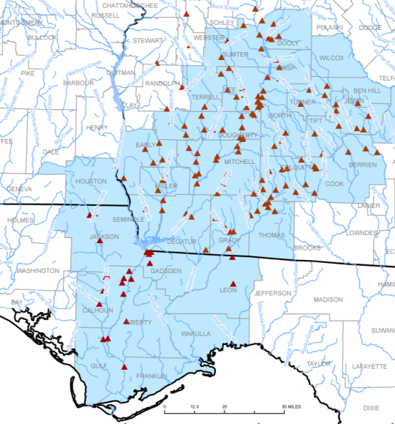
Figure 12: Surface water sites measured as part of the synoptic.
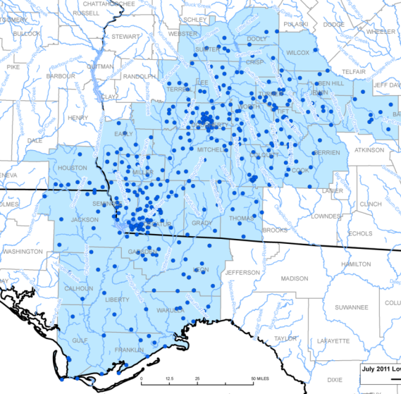
Figure 13: Groundwater sites measured as part of the synoptic.

Appendix 2

Comparison/Combination of Models to Estimate Streamflow at Ungaged Basins
Julie Kiang (OSW), Stacey Archfield (MA WSC), Lauren Hay (NRP), Steve Markstrom (NRP), Ken Eng (OSW), Dave Wolock (KS WSC), Thorsten Wagener (Penn State), and Jacob LaFontaine (GA WSC)

Introduction
Estimates of daily streamflow time series is critical to any number of hydrological investigations. Specifically, the Department of Interior Ad Hoc Advisory Committee for WaterSMART has identified a need for daily streamflow at ungaged locations to define ecological-flow goals, assess the effects of hydrologic alteration on ecological services, and understand the effects of change on water resources, such as changes from climate and land cover. Methods to estimate daily streamflow range from relatively simple statistical methods that require few input parameters to complex process-based models. Each of these models offers their own respective advantages, uncertainties, and limitations; however, a rigorous comparison, and possible combination, of these methods across varying hydroclimatic regimes is needed.

Study Area
This study will be focused in the Apalachicola-Chattahoochee-Flint River Basin (ACF, drainage area 19,200 mi²). The ACF Basin is one of the focus basins identified by WaterSMART and has been the focus of the National Climate Change Wildlife Science Center (NCCWSC) funded Southeast Regional Assessment Project (SERAP; http://serap.er.usgs.gov ) for the past three years.

General Approach
A comparison of streamflow estimates for a large-scale watershed will be made based on simulations from: 1) statistically-based methods (SBM), 2) a water balance model (WBM), and 3) a physically-based watershed model (PRMS). The initial simulations made with these models coincide with the Control Experiment in Table 4.
Next, the watershed will be considered ‘ungaged’ and new parameter sets for each Experiment shown in Table 1 will be developed and compared using:
- Daily streamflow estimated from the SBM to calibrate WBM and PRMS.
- Streamflow statistics and respective uncertainties determined from regional regression (RR) equations (Yadav and others, 2007) to constrain and determine the WBM and PRMS model parameters.
- Monthly streamflow estimated from the WBM calibrated with the measured streamflow to calibrate PRMS.
- Monthly streamflow estimated from the WBM calibrated with the SBM to calibrate PRMS.
- Monthly streamflow estimated from the WBM calibrated with the RR to calibrate PRMS.

Table 4: Experiments proposed for model comparisons.
Experiment | Source of information used for calibration | Models to be calibrated
Experiment | Source of information used for calibration | SBM | WBM | PRMS
Control | Measured Streamflow (MS) | x | x | x
1 | SBM |  | x | x
2 | Regional Regression (RR) |  | x | x
3 | WBM (MS) |  |  | x
4 | WBM (SBM) |  |  | x
5 | WBM (RR) |  |  | x

Models
Three types of models will be compared: 1) statistically-based methods (SBM), 2) water balance model (WBM), and a 3) physically-based watershed model (PRMS).

Statistically-based models (SBM)
Previously published statistically-based models by Archfield and Vogel (2010) and Archfield and others (2010) will be used to estimate daily streamflow time series at ungaged locations within the study basins. These methods scale streamflows from a gaged donor basin by some measureable characteristic or set of characteristics available at the ungaged basin. At least two such scaling methods – the drainage-area ratio (as applied by Archfield and Vogel, 2010) and the flow-duration curve/QPPQ transform method (as applied by Archfield and others, 2010) – will be developed for the study basins. Depending on time and budget constraints, additional statistical models such as top-kriging (Skøien and others, 2006; Skøien and Blöschl, 2007) could be tested for these study areas. Those who have worked to develop these methods would be sought for inclusion as collaborators on the project based on the additional methods selected to be tested.
Initially, the map correlation method (Archfield and Vogel, 2010) will be used to select the donor basin. The map correlation method is able to select the donor basin that has streamflows estimated to be most correlated with the ungaged basin. Cross-correlation between streamflow time series at an ungaged and gaged basin has been shown to be an effective metric of hydrologic similarity to select the donor basin for models proposed to be tested here. This study will also investigate alternative methods to select the donor basin, such a similarity among basin characteristics or hydrologically similar regions, as a contingency for areas where the map correlation method may not perform as well as expected. In particular, basin attributes that explain cross-correlation between basins may be used as an alternative metric to select the donor basin.
Alternatively to estimating streamflow through correlation, Yadav and others (2007; Zhang and others, 2008) suggested that signatures of watershed behavior can be regionalized. Such signatures are indices describing the functional watershed behavior such as runoff ratio, baseflow index or recession constant that can be estimated using physical and climatic watershed characteristics. Including estimates of uncertainty in the regression allows for expected values of signatures (including their probability distributions) to be estimated at ungaged locations. This information can then be assimilated into any continuous watershed model using Bayesian (Singh and others, in review) or set-theoretic (GLUE-type as used in Yadav and others, 2007) approaches. The approach therefore allows for ensemble predictions from which probability distributions of streamflow indices can be derived (e.g. ecological indicators).
Both methods, correlation analysis and signature regionalization, provide additional information to any approach through which a priori estimates of model parameters are made (Wagener and Montanari, 2011).

Water Balance Model (WBM)
The water-balance model analyses the allocation of water among various components of the hydrologic system using a monthly accounting procedure based on the methodology originally presented by Thornthwaite (Thornthwaite, 1948; McCabe and Markstrom, 2007). The WBM will be partitioned into modeling units based on an aggregation of the NHDPlus catchments. Inputs to the model are mean monthly temperature, monthly total precipitation, and the latitude of the location of interest. The WBM produces 7 output variables: potential and actual evapotranspiration, soil moisture, snowpack water equivalent, snow melt, direct surface runoff, and total runoff.

Precipitation Runoff Model (PRMS)
The watershed hydrology model PRMS (Leavesley and others, 1983; Markstrom and others, 2008) is a deterministic, distributed-parameter, process-based model used to simulate and evaluate the effects of various combinations of precipitation, climate, and land use on basin response. Response to normal and extreme rainfall and snowmelt can be simulated to evaluate changes in water-balance relations, streamflow regimes, soil-water relations, and groundwater recharge. Each hydrologic component used for generation of streamflow is represented within PRMS by a process algorithm that is based on a physical law or an empirical relation with measured or calculated characteristics.
Distributed-parameter capabilities of PRMS are provided by partitioning a basin into hydrologic response units (HRUs) which will coincide with the modeling units defined for the WBM from the aggregation of NHDPlus. For each HRU, a water balance is computed each day and an energy balance is computed twice each day. PRMS uses daily climate values of measured precipitation and maximum and minimum temperature distributed to each HRU. The HRU-distributed climate values are used to compute solar radiation, potential evapotranspiration, actual evapotranspiration, sublimation, snowmelt, streamflow, and infiltration in a PRMS simulation.

Model Calibration
An automated procedure will be developed to calibrate the WBM and PRMS experiments outlined in Table 1. The step wise, multiple objective, automated procedure used in the Luca software (Hay and Umemoto, 2006) will be enhanced to enable a nested modeling approach towards calibration of the WBM and PRMS. Calibration will start at the headwaters and proceed through the watershed by HRU, building a progressively larger model, and treating the SBM- or WBM-simulations as ‘measured’ depending on the Experiment. For this study, the automated procedure will include the sequential calibration of a model’s simulation of solar radiation, potential evapotranspiration, snowmelt, and streamflow. This process ensures that intermediate model fluxes as well as the water balance are simulated consistently with ‘measured’ values (Hay and others, 2006).

Analysis
Estimated natural daily streamflow from experiments outlined in Table 1 will be compared. In general, the comparison framework is composed of the following: (1) Establish calibration data sets (2 scenarios: 100% of calibration gages and 50% of them) and validation basins, (2) generation of daily-time series at the validation basins, (3) computation of streamflow statistics at the validation basins and development of simple methods for comparison of individual statistics, such as multiple-linear regressions, (4) performance criteria for (a) daily-time series of streamflow and (b) streamflow characteristics, such as statistical metrics calculated from the observed and estimated data, and (5) analysis of results and report(s). This framework will be used as a guide to evaluate and compare the SBM, WBM and PRMS approaches to modeling streamflow in ungaged basins.

Products
There are several expected results and possible products that follow from the approach above:
- By comparing daily streamflow estimated by the SBMs to the calibrated WBM and PRMS model results, we can provide guidance on the advantages/disadvantages/applicability of each method to estimate daily streamflow.
- Through the application of the concepts in Yadav and others (2007), we can develop an overall approach to regionalizing WBM and PRMS model parameters for ungaged basins across the United States which combines both a priori information on model parameters as well as regional information on expected watershed dynamics.
- A portal based on two prototypes: (1) current and future WBM output for the country (http://runoff.cr.usgs.gov/mows/wb/) and (2) the Southeast Regional Assessment Project Data Portal for integration of environmental simulation models (http://internalbrr.cr.usgs.gov/mows/serap/ -- click on Watershed Modeling), expanded to distribute results and relevant derivatives from this study. Note: use Firefox if viewing prototypes.
- Tools for defining HRUs and calibrating large areas that could be extended across the Nation.
- Proposed publication titles:
- “Comparison of statistically and physically based watershed models to estimate streamflow at ungaged basins”
- “Physical and climatic explanations for the cross-correlation between streamflow time series”
- Potential papers on parameter regionalization and improvements/new approaches to the statistically-based modeling

Resources/Timeline
Work will start on October 1, 2011 (FY 2012) and end in December 2012 (FY 2013). The following list includes FTE time and other resources needed for project completion.
- OSW staff (Julie Kiang and Ken Eng)
- WSC PRMS modeler, ½ time (Jacob LaFontaine)
- WSC SBM modeler, ½ time
- NRP programmers (WBM modeler, NHDPlus aggregation, portal development, and calibration software)
- Non-USGS collaborators
- Funds for computers, publications, and meetings

Appendix 3

Related Studies for Water Use
This work will build on existing programs to compile water withdrawal and consumptive use data in the region. This includes the USGS 5-year water use report, a cooperative water program study in Georgia to compile and quantify irrigation withdrawal using metered data, and research investigations using crop, climatic, and remote sensing data to estimate agricultural withdrawal.
- In Georgia, Florida, and Alabama, the USGS is compiling water withdrawal data for 2010 as part of the 5-year National water use report. Each Water Science Center is charged with compiling water withdrawals by source (surface water or groundwater) on a county basis. Concurrent with this effort, major public supply water withdrawal locations are being incorporated into the Site Specific Water Use Data System (SWUDS) to enable tracking of water movement from withdrawal point to treatment/use to return location (funded by a different source associated with WaterSMART).
- In Florida, as part of the Floridan aquifer system water-availability study (funded by the USGS Groundwater Resource Program), monthly irrigation withdrawals in Georgia, Florida, and Alabama are being estimated for 1997, 2002, and 2007 on a county basis using digital crop acreage, soil, and climatic data. If feasible, the spatial distribution of these withdrawals within individual counties will also be estimated, based on the spatial distribution of irrigation wells.
- In Arkansas and Mississippi, as part of the Integrated Assessment of Water Availability in the Southeast (IWASE), methods of monitoring irrigation and estimating evaporation through satellite remote sensing are being developed. Funding and in-kind support for this collaborative effort involving 3 USGS Science Centers, the USDA, and state agencies will be leveraged with those from the ACF WaterSMART pilot to further test and refine these approaches in both the Yazoo River Delta and the ACF.
- In Georgia, a cooperative program with the Georgia Soil and Water Conservation Commission is compiling and analyzing irrigation withdrawal data from a network of over 10,000 sites equipped with totalizing meters, of which nearly 200 transmit withdrawal data on daily basis using satellite telemetry (Figure 14). Although some irrigation withdrawal data exists in Florida, there is no equivalent metered data set available in Alabama or Florida, so estimation techniques need to be employed in these areas. Data from the Georgia Metering Program (GaMP) and other available data from Florida will be used to help evaluate techniques to estimate irrigation withdrawal based on climatic, crop acreage, and satellite image processing techniques that identify irrigated lands and estimate consumptive use from evapotranspiration.
- As part of WaterSMART, a group of USGS researchers (Phillip Zarriello, Stephen Preston, Molly Maupin, and Sara Levin) have developed an estimation method based on logistical regression for evaluating irrigation water use at the National level. The method involves a set of 300,000 data sites obtained from an NRCS-NRI data base of 1992 or 1997 irrigation locations. To facilitate these studies, the USGS research group has requested the GaMP data for comparison with the logistical regression estimates of irrigation locations in the ACF basin.

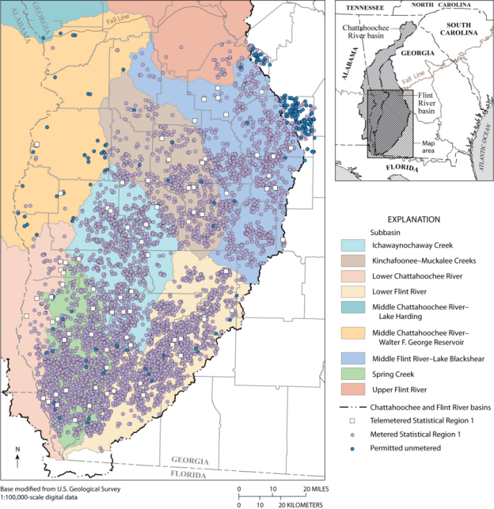
Figure 14: Locations of permitted unmetered and metered agricultural water-use sites in the middle-and-lower Chattahoochee and Flint River basins at the end of 2009 (From Torak and Painter, 2011).

Appendix 4

Environmental Flows-ACF Context
The Apalachicola-Chattahoochee-Flint (ACF) River Basin is an extensive alluvial system that drains an area of about 48,500 km² (18,726 mi²) extending from the Piedmont to the Gulf Coastal plain through north-central and western Georgia, southeastern Alabama, and northern Florida (Figure 15). By magnitude of discharge the ACF basin is the 21st largest in the coterminous United States. It is also a highly regulated basin with 13 dams on the Chattahoochee River and 3 on the Flint River. The basin is a regionally important source of water for human use, recreation, and hydropower.
Freshwater flow into Apalachicola Bay is the driving force that sustains ecology of the bay. Food webs that link the production of commercially important organisms (e.g., oysters, shrimp, crabs, finfishes) are affected by river flows that control salinity regimes and nutrient dynamics (Livingston, 2008).
The aquatic fauna of the ACF basin has high species richness and endemism, although somewhat less than other prominent drainages of the Southeast (i.e., Mobile and Tennessee River basins). Approximate numbers of native species in the ACF basin are as follows (number endemic in parentheses): 83 snails (number endemic unknown); mussels, 33 (8); crayfishes, 30 (12); fishes, 125 (9). Additionally, the basin has a relatively high number of imperiled taxa, as indicated by either federal listing under the Endangered Species Act or as recognized by expert scientists representing the American Fisheries Society (AFS). Lists of imperiled species of crayfishes and fishes have recently been published by the AFS (Taylor and others, 2008; Jelks and others, 2008;
Table 5, Table 6), and lists of mussels (Table 7) and snails are currently in preparation.
Resource management objectives include sustaining ecological conditions that support the Clean Water Act goals of maintaining biological integrity and the persistence of imperiled species. Although listed taxa are of primary concern to the U.S. Fish and Wildlife Service and stakeholder groups, many species that do not currently merit protection under the Endangered Species Act are of interest in ACF basin due to vulnerability from hydrologic alteration.
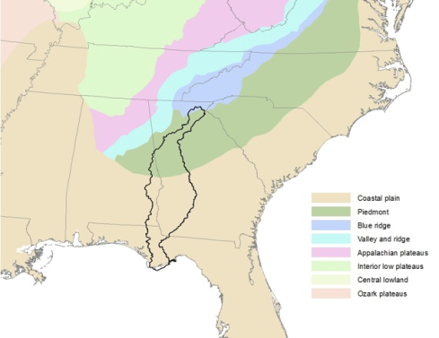
Figure 15: Outline of ACF basin in relation to provinces and southeastern states.

Table 5: Crayfishes of the ACF basin and conservation status as recognized by the American Fisheries Society (Taylor and others, 2007). CS = currently stable; V = vulnerable; T = threatened; E = endangered; † = species complex currently under study). Crayfishes are not targeted in the present study; however, many rheophilic species share vulnerability to hydrologic alterations in common with other aquatic fauna.
Species | Common Name | AFS Status
Cambarellus schmitti Hobbs, 1942 | Fontal Dwarf Crawfish | CS
Cambarus acanthura Hobbs, 1981 | Thornytail Crayfish | CS
Cambarus cryptodytes Hobbs, 1941 | Dougherty Plain Cave Crayfish | T
Cambarus diogenes Girard, 1852 | Devil Crawfish | †CS
Cambarus doughertyensis Cooper & Skelton | Dougherty Burrowing Crayfish | E
Cambarus harti Hobbs, 1981 | Piedmont Blue Burrower | E
Cambarus howardi Hobbs & Hall, 1969 | Chattahoochee Crayfish | CS
Cambarus latimanus (Le Conte, 1856) | Variable Crayfish | CS
Cambarus nodosus Bouchard & Hobbs, 1976 | Knotty Burrowing Crayfish | CS
Cambarus pyronotus Bouchard, 1978 | Fireback Crayfish | E
Cambarus striatus Hay, 1902 | Ambiguous Crayfish | CS
Faxonella clypeata (Hay, 1899) | Ditch Fencing Crayfish | CS
Orconectes pardalotus Wetzel, Poly & Fetzner, 2005 | Leopard Crayfish | E
Procambarus acutissimus (Girard, 1852) | Sharpnose Crayfish | CS
Procambarus apalachicolae Hobbs, 1942 | Coastal Flatwoods Crayfish | T
Procambarus gibbus Hobbs, 1969 | Muckalee Crayfish | T
Procambarus howellae Hobbs, 1952 | Ornate Crayfish | CS
Procambarus kilbyi (Hobbs, 1940) | Hatchet Crayfish | CS
Procambarus latipleurum Hobbs, 1942 | Wingtail Crayfish | V
Procambarus leonensis Hobbs, 1942 | Blacknose Crayfish | CS
Procambarus lewisi Hobbs & Walton, 1959 | Spur Crayfish | V
Procambarus paeninsulanus (Faxon, 1914) | Peninsula Crayfish | CS
Procambarus pycnogonopodus Hobbs, 1942 | Stud Crayfish | CS
Procambarus pygmaeus Hobbs, 1942 | Christmas Tree Crayfish | CS
Procambarus rogersi expletus Hobbs & Hart, 1959 | Perfect Crayfish | E
Procambarus rogersi rogersi (Hobbs, 1938) | Seepage Crayfish | E
Procambarus spiculifer (Le Conte, 1856) | White Tubercled Crayfish | †CS
Procambarus verrucosus Hobbs, 1952 | Grainy Crayfish | CS
Procambarus versutus (Hagen, 1870) | Sly Crayfish | CS
Procambarus youngi Hobbs, 1942 | Florida Longbeak Crayfish | T

Table 6: Imperiled fishes of the ACF basin as recognized by the American Fisheries Society (Warren and others, 2000, Jelks and others, 2008). V = vulnerable; T = threatened.
Species | Common Name | AFS Status
Acipenser oxyrinchus desotoi Vladykov, 1955 | Gulf Sturgeon¹ | T
Alosa alabamae Jordan & Evermann, 1896 | Alabama Shad | T
Ameiurus brunneus Jordan, 1877 | Snail Bullhead | V
Ameiurus serracanthus (Yerger & Relyea, 1968) | Spotted Bullhead | V
Cyprinella callitaenia (Bailey & Gibbs, 1956) | Bluestripe Shiner | V
Micropterus cataractae Williams & Burgess, 1999 | Shoal Bass | V
Morone saxatilis (Walbaum, 1792) | Striped Bass² | V
Notropis chalybaeus (Cope, 1867) | Ironcolor Shiner | V
Notropis hypsilepis Suttkus & Raney, 1955 | Highscale Shiner | V
Percina crypta Freeman, Freeman, & Burkhead, 2008 | Halloween Darter | V
Pteronotropis euryzonus (Suttkus, 1955) | Broadstripe Shiner | V
Pteronotropis welaka (Evermann & Kendall, 1898) | Bluenose Shiner | V
¹ Listed as threatened under the U.S. Endangered Species Act.
² Refers to Gulf of Mexico populations only.

Table 7: Freshwater mussels (Unionidae) of the ACF basin and conservation status as recognized by the U.S. Fish and Wildlife Service (USFWS) and the American Fisheries Society (in prep.). V = vulnerable; T = threatened; E = endangered.
Species | Common Name | Federal Status | AFS Status
Alasmidonta triangulata | Southern Elktoe | Petitioned | E
Amblema neislerii | Fat Threeridge | Listed -E | E
Anodonta heardi | Apalachicola Floater | Petitioned | V
Anodontoides radiatus | Rayed Creekshell | Petitioned | V
Elliptio arctata | Delicate Spike | Petitioned | T
Elliptio chipolaensis | Chipola Slabshell | Listed -T | T
Elliptio crassidens | Elephantear |  | V
Elliptio fraterna | Brother Spike | Petitioned | E
Elliptio fumata | Gulf Slabshell |  | CS
Elliptio nigella | Winged Spike |  | E
Elliptio pullata | Gulf Spike |  | CS
Elliptio purpurella | Inflated Spike | Petitioned | V
Elliptoideus sloatianus | Purple Bankclimber | Listed -T | E
Fusconaia apalachicola | Apalachicola Ebonyshell | Extinct | X
Glebula rotundata | Round Pearlshell |  | CS
Hamiota subangulata | Shinyrayed Pocketbook | Listed -E | E
Lampsilis binominata | Lined Pocketbook |  | PX
Lampsilis flordensis | Florida Sandshell |  | CS
Lampsilis straminea | Southern Fatmucket |  | CS
Lasmigona subviridis | Green Floater |  | T
Medionidus penicillatus | Gulf Moccasinshell | Listed -E | E
Megalonaias nervosa | Washboard |  | CS
Pleurobema pyriforme | Oval Pigtoe | Listed -E | E
Pyganodon cataracta | Eastern Floater |  | CS
Pyganodon grandis | Giant Floater |  | CS
Quadrula infucata | Sculptured Pigtoe |  | V
Toxolasma parvum | Lilliput |  | CS
Toxolasma paulum | Iridescent Lilliput |  | CS
Uniomerus columbensis | Apalachicola Pondhorn |  | CS
Utterbackia imbecillis | Paper Pondshell |  | CS
Utterbackia peggyae | Florida Floater |  | CS
Villosa lienosa | Little Spectaclecase |  | CS
Villosa vibex | Southern Rainbow |  | CS
Villosa villosa | Downy Rainbow |  | V

“Environmental flows” have been defined as “the quantity, quality and timing of water flows required to sustain freshwater and estuarine ecosystems and the human livelihoods and well-being that depend on these ecosystems” (“Brisbane Declaration”; Poff and others, 2010).
Additional background on related studies, the synoptic for the ACF completed last summer, as well as the model comparisons done for the Office of Surface Water can be found in the Appendices.

